Ñan ad loore Environmental Protection Agency (EPA, Agency in Kōjbarok Ta ko Belaakid) kakien, jerbal ko ikijen dān ko an loblej ej aikuj ñan an dedelak lain in jerbal ko an riwia ro. Laajrak in kajitok in elap an jibāñ ikijen dān ko an loblej bwe en lorlorjake jekjek in ilo an jimwe. Kōmmeḷeḷe kein ilal renij jibāñ eok kalikkar ta eo lain in jerbal e dān eo am ej kōmman jān e.

# Bukwot Lain in Jerbal Dān eo Am

Mokta jān am kanne laajrak in kajitok kein, kwoj aikuj kalikkar ia eo lain in jerbal e dān eo am ej pād e im waween an koneek ñan mweo imōm. Ñe kwoj aikuj jibāñ bukot lain in jerbal eo am, topar lak jikin jerbal e dān ko an loblej ilo jiped ijin ñan kadelon melele ko ikijen topar jikin jerbal dān.

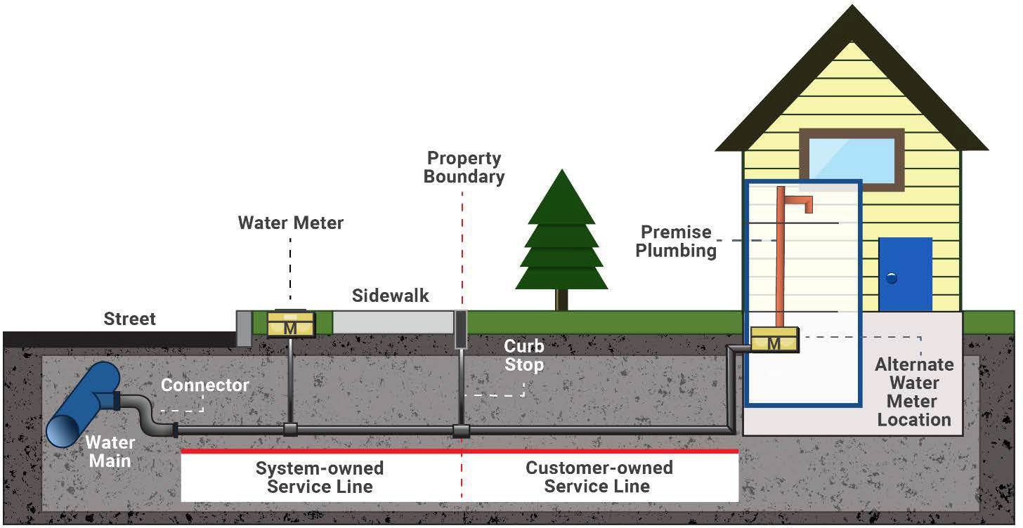

Ial eo

Mita in Dān

Jikin Etetal ilo Torerein Ial

Belaakin Juon Bwidej

Baib ko ilo Juon Jikin

Lain in jerbal ko an jikin jerbal eo

Lain in jerbal an juon māke riwia

Oktak ijo mita in dān eo ej pād ie

Lain eo ekka an dān duoj jān e

Kein koneek

Bojet in Kabōjrak an Toor Dān

## Mita in Dān ilo Naboj ak Bojet in Kabōjrak an Toor Dān

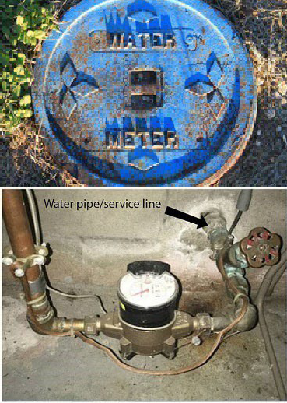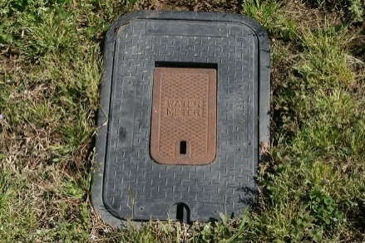Ñan bukot ia eo lain in jerbal an dān ej deḷọñ ilo mweo imōm, kabbok mita in dān im bojet in kabōjrak an toor dān. Ekka an walok ilo maan in bwidej eo am turin ial eo ak jikin etetal ko torerein ial im rej pād ilo bọọk ko lal emōj kakōḷḷe "dān" ak "mita". Elikin am lore ir, loore ial eo ekadu tata ñan mweo imōm. Lain in jerbal eo an dān ej aikuj deloñ ilowaan mweo jān tulal ak dāpin mweo ilo jikin in.

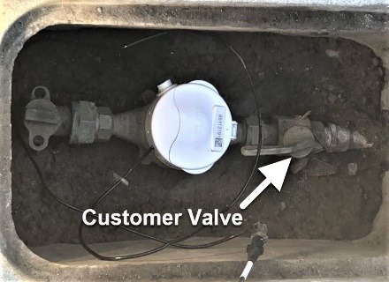

Bojet an Riwia

## Teej e ta eo Baib eo ej Kōmman jān E

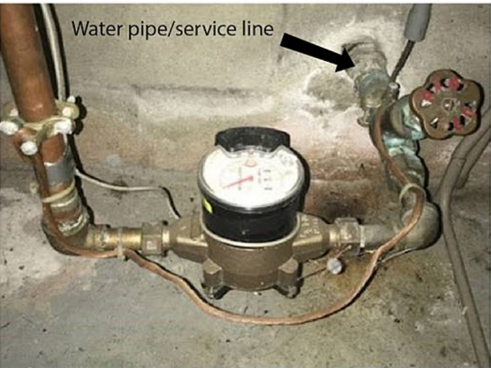

Baib in dān/lain in jerbal

Ñe emōj am lore ia eo lain in jerbal dān eo ej deḷọñ ilo mweo imōm, kabbok juon jikin ilo baib eo epāāke tata dāpin mweo ak tulal mokta jān an koneek ñan juon bojet ak mita. Ilo ijin, komaroñ teej e ta eo baib eo ej kōmman jān e. Aurok bwe kwon bukot baib eo ej deloñ ilo mweo imōm.

### Teej e Kein Jerbal ko

Kōjerbale kein jerbal kein emōj laajrak ñan kalikkar ta eo baib eo ilo lain in jerbal dān eo ej kōmman jān e.

* **Jitūūl an aij bọọk ak bar jōt kain jitūūl**—kōjerbale ñan teej ñe baib eo ej kōmman jān steel ak aen.

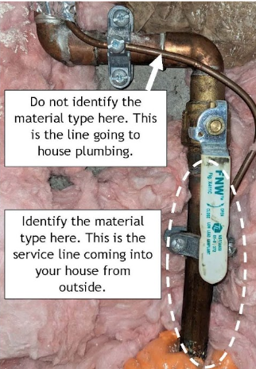

Jab kwalōk ta eo ej kōmman jān e ijin. Lain eo in ej etal ñan baib ko lowaan mweo.

Kwalōk ta eo ej kōmman jān e ijin. Lain in jerbal eo in ej deloñ lowaan mweo imōm jān naboj.

* **Kein jikūru ak jāān deka**—ñan kwalōk lukkun kolar in baib eo ñan kwalōk kolar in aen eo im joñan ben im lale ainikien.
* **Teñki ak cell phone**—kōjerbale meram ñan lale baib eo.
* **Lead**—Teej in Lale Kurar: Ebidodo an kurar. Ñe jikin eo ekurar errabōlbōl im jelba, baib eo ej lead. Teej in Jitūūl: Juon jitūūl eban eddep ñan juon lead baib. Teej in Lale Ainikien: Teej in lale ainikien juon lead baib kin juon jāān deka enij kōmman juon ainikien eo edik.
* **Koba**—Teej in Lale Kurar: Ñe jikin eo ekurar ej kolar in koba, āinwot juon jāān koba, baib eo ej koba. Teej in Jitūūl: Juon jitūūl eban eddep ñan juon baib kōba. Teej in Lale Ainikien: Lale ainikien juon baib koba kin juon jāān deka enij kōmmane juon ainikien aen eo ej riñ.
* **Galvanized Steel ak Aen**—Teej in Lale Kurar. Ñe jikin eo ekurar ej pād wōt ilo an kūre, baib eo ej galvanized steel. Teej in Jitūūl: Juon jitūūl ej eddep ñan juon baib eo ebin. Teej in Lale Ainikien: Lale ainikien juon baib eo ebin kin juon jāān deka enij kōmmane juon aikien aen eo ej riñ.
* **Būḷajtiik**—Baib in ej kōmman jān eloñ kain im kolar. Babe eo ejjab kōmman juon ainikien eo ej riñ ñe ej lale ainikien kin juon jāān deka ak kein jikūru.

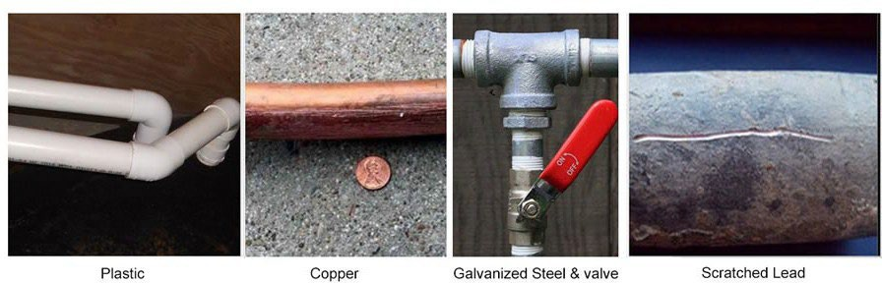

Būḷajtiik

Koba

Galvanized Steel & bojet

Lead eo emōj an kurar

# Laajrak in Kajitok ikijen Jerbal ko an Lain in Dān an Riwia

|  |  |
| --- | --- |
| **Melele ko ikijen Jikin** | |
| **Jikin Jokwe:** Jiped ijin ñan likit jeje. | |
| **Kiaptōl:** Jiped ijin ñan likit jeje. | **Zip code eo:**  Jiped ijin ñan likit jeje. |

|  |  |  |  |  |
| --- | --- | --- | --- | --- |
| **Jouj uak e laajrak in kajitok kein.** | | | | |
| **Am māke ijin ke ak kwoj reen e?** | | Aō māke | | Reen |
| **Yiiō ta eo mwiin ekar ekkal?** Jiped ijin ñan likit jeje. | | | | |
| **Ilo jella eo am māke, emōj ke an kakaal lain in jerbal e dān ilo mweo imōm juon alen?** | | | | |
| Aet | **Yiiō ta eo mwiin ekar kakaal?** Jiped ijin ñan likit jeje. | | | |
| Jab | | | | |
| Jab jella | | | | |
| **Ta eo lain in jerbal e dān eo am ej kōmman jān e? Komaroñ kelet elaplok jān juon.** | | | | |
| Lead | | | Koba | |
| Steel (baib ej kōmman jān aen, galvanized) | | | Būḷajtiik (HDPE, PVC) | |
| Jab jella | | | Jab maroñ bukot lain in jerbal | |
| **Ewi waween am jella ta eo ej kōmman jān e? Kelet juon.** | | | | |
| Teej in Lale Kurar | | | Am kalimjok e | |
| Jab maroñ bukot lain in jerbal | | | Juon rijerbal eo elap an jella kin baib ak juon bar rijerbal eo elap jella ippān | |
| **Koṃṃool. Jouj im karoltok laajrak in kajitok kein ñan armij in emōj karōk e ilal.**  Likit waween topar eo ilo jerbal ko an dān. | | | | |

# Ñan Melele ko Relaplak

Bukot elaplok kein jibāñ ilo [Ta ko Kōbban Lain in Jerbal iumin Lead—EPA webjait ikijen Lead im Kōba Kakien ko Emōj kakaal](https://doh.wa.gov/community-and-environment/drinking-water/contaminants/lead/lead-and-copper-rule-revisions) (ilo Kajin Pālle).

## Webjait Atōrej eo an Jerbal in Dān ko an Loblej

Likit webjait URL eo an jikin jerbal in dān ijin.

Logo

Kōmmeḷeḷe ko rej māke deloñ ijin.

Ñan kajjitōk bwe ren lewōj peba in ilo bar juon wāwein, kwōn kaḷḷọk 1-800-525-0127. Armej ro rej jarroñroñ ren kaḷḷọk 711 (Washington Relay) ak email [doh.information@doh.wa.gov.](jilkinlakñan:doh.information@doh.wa.gov.) Ñe kwoj aikuj jerbal in ukok kajin, kurlok 1-800-525-0127.