Notice of Confirmed Lead Service Line
< Public Water System (PWS) name > is focused on protecting the health of every household in our community. This notice contains important information about your drinking water. Please share this information with anyone who drinks and/or cooks using water at this property. In addition to people directly served at this property, this can include people in apartments, nursing homes, schools, businesses, as well as parents served by childcare at this property.

< PWS name > has determined that < a portion of or the entire > water pipe (called a service line) that connects your < home, building, or other structure > to the water main is made from lead. People living in homes with a lead service line may have an increased risk of exposure to lead from their drinking water.
< The figure below represents a typical scenario for a residence in many cases but does not represent all scenarios. Water systems may wish to replace the image with one of their own or remove it.>

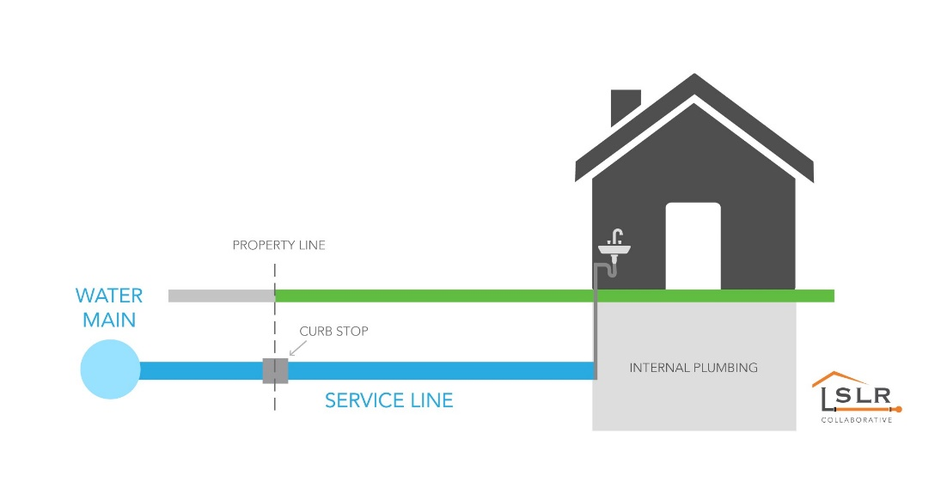

Health Effects of Lead
Exposure to lead in drinking water can cause serious health effects in all age groups. Infants and children can have decreases in IQ and attention span. Lead exposure can lead to new learning and behavior problems or worsen existing learning and behavior problems. The children of women who are exposed to lead before or during pregnancy can have increased risk of these negative health effects. Adults can have increased risks of heart disease, high blood pressure, and kidney, or nervous system problems.*
*Text in italics is required and cannot be changed.

Steps to Reduce Lead in Drinking Water
Below are recommended actions that you may take, separately or in combination, if you are concerned about lead in your drinking water. The list also includes where you may find more information. It is not intended as a complete list. It does not imply that all actions equally reduce lead in drinking water.
Use your filter properly. Using a filter can reduce lead in drinking water. If you use a filter, it should be certified to remove lead. Read any directions provided with the filter to learn how to properly install, maintain, and use your cartridge and when to replace it. Using the cartridge after it has expired makes it less effective at removing lead. Do not run hot water through the filter. For more information on facts and advice on home water filtration systems, visit EPA’s filters to reduce lead website.
Clean your aerator. Regularly remove and clean your faucet’s screen (also known as an aerator). Sediment, debris, and lead particles can collect in your aerator. If lead particles are caught in the aerator, lead can get into your water.
Use cold water. Do not use hot water from the tap for drinking, cooking, or making baby formula as lead dissolves more easily into hot water. Boiling water does not remove lead from water.
< Areas prone to drought or currently experiencing scarcity of water may want to omit or edit this recommendation. > Run your water. The more time water has been sitting in pipes providing water to your home, the more lead it may contain. Before drinking, flush your home’s pipes by running the tap, taking a shower, doing laundry, or doing a load of dishes. The amount of time to run the water depends on whether your home has a lead service line or not, as well as the length and diameter of the service line and the amount of plumbing in your home. [Include tailored flushing information, if appropriate, or add following language] Residents may contact us at [phone number and/or email address] for recommendations about flushing times in their community.
Learn what your service line material is. Contact us at [phone number and/or email address] or a licensed plumber to determine if the pipe that connects your home to the water main (called a service line) is made from lead, galvanized, or other materials. [For systems replacing lead service lines consider the following text.] To learn about what we are doing to replace lead service lines, please visit [website] or contact us at [phone number and/or email address]. Protect Your Tap: A quick check for lead is EPA’s on-line step by step guide to learn how to find lead pipes in your home.
Learn about construction in your neighborhood. Contact us at [phone number and/or email address] to find out about any construction or maintenance work that could disturb your service line. Construction may cause more lead to be released from a lead service line or galvanized service line if present.
Have your water tested. Contact us, your water utility, at < insert PWS contact information – phone, email, etc.> to have your water tested and to learn more about the lead levels in your drinking water. Alternatively, you may contact a certified laboratory to have your water tested for lead. A list of certified laboratories is available at < provide location of list or explain your water system’s testing program and any costs to customer if one exists>. Note, a water sample may not adequately capture or represent all sources of lead that may be present. Visit EPA’s basic information webpage for information on sources of lead that include service lines and interior plumbing.

Test Your Child to Determine their Blood Lead Levels
A family doctor or pediatrician can perform a blood test for lead and provide information about the health effects of lead. State, city, or county departments of health can also provide information about how you can have your child's blood tested for lead. The Centers for Disease Control and Prevention recommends public health actions when the level of lead in a child’s blood is 3.5 micrograms per deciliter (µg/dL) or more. Visit EPA’s Basic Information website for more information and links to CDC’s website.

Replacing Lead Service Lines
<Insert information about your water system’s lead service line replacement program, if applicable, or other opportunities to replace lead service lines.>
If you are planning on replacing the portion of the service line that you own, please notify us at <insert PWS contact information – phone, email, etc.>.
For information about potential financing solutions to assist property owners with replacement of lead service lines, please contact us at <insert PWS contact information – phone, email, etc.>.
For more information on reducing lead exposure from your drinking water and the health effects of lead, visit EPA’s Lead website.


To request this document in another format, call 1-800-525-0127. Deaf or hard of hearing customers, please call 711 (Washington Relay) or email doh.information@doh.wa.gov. If in need of translation services, call 1-800-525-0127.

Regulatory Text in Title 40, Code of Federal Regulations (CFR))

§ 141.85 (e) Notification of known or potential service line containing lead.
(1) Notification requirements. All water systems with lead, galvanized requiring replacement, or lead status unknown service lines in their inventory pursuant to § 141.84(a) must inform all persons served by the water system at the service connection with a lead, galvanized requiring replacement, or lead status unknown service line.
(2) Timing of notification. A water system must provide the initial notification within 30 days of completion of the lead service line inventory required under § 141.84 and repeat the notification on an annual basis until the entire service connection is no longer a lead, galvanized requiring replacement, or lead status unknown service line. For new customers, water systems shall also provide the notice at the time of service initiation.
(3) Content -
(i) Persons served by a confirmed lead service line. The notice must include a statement that the person's service line is lead, an explanation of the health effects of lead that meets the requirements of paragraph (a)(1)(ii) of this section, steps persons at the service connection can take to reduce exposure to lead in drinking water, information about opportunities to replace lead service lines as well as programs that provide financing solutions to assist property owners with replacement of their portion of a lead service line, and a statement that the water system is required to replace its portion of a lead service line when the property owner notifies them they are replacing their portion of the lead service line.
(ii) Persons served by a galvanized requiring replacement service line. The notice must include a statement that the person's service line is galvanized requiring replacement, an explanation of the health effects of lead, steps persons at the service connection can take to reduce exposure to lead in drinking water, and information about opportunities for replacement of the service line.
(iii) Persons served by a lead status unknown service line. The notice must include a statement that the person's service line material is unknown but may be lead, an explanation of the health effects of lead that meets the requirements of paragraph (a)(1)(ii) of this section, steps persons at the service connection can take to reduce exposure to lead in drinking water, and information about opportunities to verify the material of the service line.
(4) Delivery. The required notice to persons served by the water system at the service connection with a lead, galvanized requiring replacement, or lead status unknown service line must be provided by mail or by another method approved by the State.

