PART 2: DESIGN STANDARDS & CONSTRUCTION (MAHC 4.0)
Subpart A: Plan Submittal and Construction Permits
WAC 246-261-401000 Construction Permits
(1) Construction Permit. Prior to construction or ALTERATION of an AQUATIC FACILITY, the owner shall obtain a construction permit issued by the DEPARTMENT or LOCAL HEALTH OFFICER. Construction permits issued by the AHJ are valid for eighteen 18 months. The DEPARTMENT or LOCAL HEALTH OFFICER may extend the life of the construction permit by up to 12 months if requested by the owner or the owner’s representative. Once a construction permit expires, the owner is responsible for resubmitting an application for a construction permit.
(2) Approved Plans. In order to obtain a construction permit, the owner shall submit a complete plan to the department or local health officer for review and approval.
(3) Permit Issuance. No permit may be issued without approved plans. Permits shall be issued within 30 days of plan approval.
(4) Permit Denial. The construction permit may be withheld, suspended, revoked, or denied by the DEPARTMENT or LOCAL HEALTH OFFICER for noncompliance with the requirements of this chapter, and the owner will be provided:
(a) Specific reasons for the action taken and procedure for resubmittal;
(b) Notice of the rights to appeal and procedures for requesting an appeal; and
(c) Reviewer’s name, signature, and date of review and the action taken.
(5) Suspension or Revocation of Construction Permit. The DEPARTMENT or LOCAL HEALTH OFFICER may suspend or revoke a construction permit issued under the provisions of this chapter in case of any false statement or misrepresentation of fact in the application or on the construction documents on which the approval was based.
(6) Stop Work Orders. Upon notice from the DEPARTMENT or LOCAL HEALTH OFFICER, work on any system that is being performed contrary to the provisions of this chapter shall immediately cease. Such notice shall be in writing and shall be given to the owner, the owner's authorized agent, or to the person performing the work. The notice shall state the condition under which work is authorized to resume.
WAC 246-261-401010 Plan Submittal (2023 MAHC 4.1.1)
(1) Plans. AQUATIC FACILITY plans shall include all necessary construction documents to provide sufficient clarity to indicate the location, nature, and extent of the work proposed. Necessary construction documents include, but are not limited to, the documents listed in Subpart B, Content of Plans, and any additional information the department or Local Health Officer may request to determine compliance with this chapter.
(2) Conform. AQUATIC FACILITY plans shall show in detail that the AQUATIC FACILITY will conform to the provisions of this chapter as determined by the department or local health officer and to protect the health and SAFETY of the facility’s BATHERS and PATRONS. Plans shall also conform to all other applicable local, state, territorial, federal, and tribal laws.
(3) Plan Preparation. All plans shall be prepared, stamped, and signed by a DESIGN PROFESSIONAL proficient in the application of this chapter and all applicable local, state, territorial, federal, and tribal laws relevant to the project and who shall apply this chapter and all applicable laws when preparing project plans.
(4) Minor Alterations. Minor ALTERATIONS that do not have the potential to affect system hydraulics, air quality, structural integrity, or PATRON safety and health may apply to the DEPARTMENT or LOCAL HEALTH OFFICER for variance from requirements for plan preparation by a DESIGN PROFESSIONAL. The DEPARTMENT or LOCAL HEALTH JURISDICTION shall have sole discretion to approve or deny an application for variance.
(5) Required Statements. All plans shall include the following statements:
(a) “The proposed AQUATIC FACILITY and all equipment shall be constructed and installed in conformity with the approved plans and specifications,” and
(b) “No ALTERATIONS, changes, additions, or equipment not specified in the approved plans can be made or added until the plans for such ALTERATIONS, changes, additions, or equipment are submitted to and approved by the DEPARTMENT or LOCAL HEALTH OFFICER.”
Subpart B: Content of Plans
WAC 246-261-401021 Application and Site Information (2023 MAHC 4.1.2/4.1.2.1) AQUATIC FACILITY plans shall include:
(1) Names / Addresses. The name, address, and contact information for the owner, DESIGN PROFESSIONAL, and builder if available at the time of submission;
(2) Site Information. Relevant site information as dictated by the project scope of work. Site information may include the location of all utilities, wells, topography, natural water features, and potential sources of surface drainage;
(3) Plot Plan. Site plot plan including:
(a) A general map and detailed scaled drawings of the AQUATIC FACILITY site plan or floor plan with detailed locations of the AQUATIC VENUES, AQUATIC FEATURES, and HYGIENE FACILITIES; and
(b) The locations of all water supply facilities, sources of drinking water, public or private sewers, and
relative elevations of paved or other walkways and the EQUIPMENT ROOM floor shall be shown on the
plans with the elevations of storm and sanitary sewer inverts and street grade.
WAC 246-261-401022 Plans Details (2023 MAHC 4.1.2.2)
(1) Drawings. Detailed scaled and dimensional drawings for each individual AQUATIC VENUE shall include an AQUATIC VENUE area plan and layout plan along with dimensioned longitudinal and transverse cross sections of the AQUATIC VENUE.
(2) Operating Conditions. The plan shall include a proposal of anticipated operating conditions (water temperature(s), space temperature, space relative humidity, space dew point) and intended use for each type of VENUE (FLAT WATER, AGITATED WATER, HOT WATER) accepted by both the DESIGN PROFESSIONAL and owner/operator.
(3) Aquatic Venue Attributes. Detailed scaled and dimensional drawings for each individual AQUATIC VENUE shall include location and type of:
(a) INLETS;
(b) Overflows;
(c) Drains, including one or more cross-sections through the main drain;
(d) Suction outlets;
(e) Overflow gutters or devices;
(f) Piping;
(g) POOL design waterline;
(h) AQUATIC VENUE basins including bottom and sidewalls;
(i) AQUATIC FEATURES;
(j) Lighting;
(k) POOL markings; and
(l) Surface materials.
(3) Area Design. Detailed scaled and dimensional drawings of the AQUATIC FACILITY and for each individual AQUATIC VENUE, as appropriate, shall include location and type of:
(a) Design of AQUATIC VENUE ENCLOSURE including walls, fencing, entry and exit doors and gates, self-closing and latching hardware, and locks;
(b) Detailed view of the EQUIPMENT ROOM layout;
(c) Design of DECK, including paving materials, DECK slope, and DECK drains;
(d) Paved walkways and other hardscape features;
(e) SLIP-RESISTANT flooring;
(f) AQUATIC VENUE area finishes;
(g) Drinking fountains or other sources of drinking water;
(h) Entries and exits;
(i) Hose bibs;
(j) Fences;
(k) Telephones; and
(l) Area lighting, including photometric plans.
(4) Aquatic Venue Recirculation and Treatment Design. Detailed scaled and dimensional drawings for each individual AQUATIC VENUE shall contain a flow diagram showing the location, plan, elevation, and schematics of:
(a) Filters;
(b) Pumps;
(c) Chemical feeders and interlocks;
(d) Chemical controllers and interlocks;
(e) SECONDARY TREATMENT;
(f) Supplemental DISINFECTION systems;
(g) Ventilation devices or AIR HANDLING SYSTEMS;
(h) Heaters;
(i) Surge tanks, including operating levels;
(j) BACKFLOW prevention assemblies and air gaps;
(k) Valves;
(l) Piping;
(m) Flow meters;
(n) Gauges;
(o) Thermometers;
(p) Test cocks;
(q) Sight glasses; and
(r) Drainage system for the disposal of AQUATIC VENUE water and filter wastewater.
(5) Equipment Room Design. Detailed scaled and dimensional drawings for each individual AQUATIC VENUE shall contain a schematic layout of the AQUATIC VENUE EQUIPMENT ROOM showing accessibility for installation and maintenance.
(6) Chemical Storage Space Design. Detailed scaled and dimensional drawings for each individual AQUATIC VENUE shall contain a schematic layout of the AQUATIC FACILITY CHEMICAL STORAGE SPACE(S).
(7) Hygiene Facility Design. Detailed scaled and dimensional drawings for each AQUATIC FACILITY shall show the location and number of all available HYGIENE FACILITIES provided including dressing rooms, lockers, SHOWERS, lavatory, toilet FIXTURES, and DIAPER-CHANGING STATIONS.
WAC 246-261-401023 Technical Specifications (2023 MAHC 4.1.2.3)
(1) Accompanying Drawings. Technical specifications for the construction of each AQUATIC VENUE and all appurtenances shall accompany the drawings for the AQUATIC FACILITY plans.
(2) Technical Details.
(a) Technical Specifications. The following technical specifications shall be provided for each AQUATIC FACILITY:
(i) Water temperatures for each AQUATIC VENUE;
(ii) Effective surface area of each AQUATIC VENUE;
(iii) Space design:
(A) Listing of each room size (length, width, height).
(iv) Design/desired dry bulb and dew point temperatures;
(v) Design/desired relative humidity;
(vi) Type of water treatment; and
(vii) PERIMETER DECK and POOL DECK, which are the same as the WET DECK area defined in the ASHRAE 62.1.2019 Standard, which defines this area as the “area surrounding the POOL surface that is capable of being wetted during use or when POOL is occupied.”

(b) Details Not Shown on Plans. Each AQUATIC VENUE shall include all construction details not shown on the plans that relate to the AQUATIC FACILITY:
(c) Intended Use. During the design of the ventilation and CLIMATE CONTROL SYSTEMS for INDOOR AQUATIC FACILITIES, the DESIGN PROFESSIONALS shall consult with and obtain input from the owner/operator to address intended uses, type of AQUATIC VENUES and intended typical operating water temperatures, space air temperature, and relative humidity.
(d) Design Criteria Document. A design criteria document shall be written as a result of these consultations, signed by all parties involved and become a permanent document of the project specifications and owner’s manual.
(3) Water Sources. The technical specifications for each AQUATIC FACILITY shall include the sources of all water supplies.
(4) Area and Volume. Technical specifications shall include the water surface area and volume of each AQUATIC VENUE and associated water features, if applicable.
(5) Theoretical Peak Occupancy. The technical specifications for each AQUATIC FACILITY and each AQUATIC VENUE shall include THEORETICAL PEAK OCCUPANCY, respectively.
(a) Used for Designing Systems. The THEORETICAL PEAK OCCUPANCY for ventilation air for an AQUATIC VENUE shall be used for designing systems that serve BATHERS and PATRONS.
(b) Incorporate Non-Water Related Areas. The THEORETICAL PEAK OCCUPANCY for an AQUATIC FACILITY shall be used for designing systems that serve BATHERS and PATRONS and shall incorporate non-water related areas such as DECKS and other adjacent portions of the AQUATIC FACILITY not associated with the AQUATIC VENUE.
(c) Calculating Theoretical Peak Occupancy. The THEORETICAL PEAK OCCUPANCY shall be calculated by dividing the surface area in square feet of the AQUATIC VENUE by the density factor (D) that fits the specific AQUATIC VENUE being considered.
THEORETICAL PEAK OCCUPANCY = AQUATIC VENUE Surface Area / D +
(i) The density factors (D) are Water/BATHER-related:
(A) Deep water density factor = 30 ft² (2.79 m²) per BATHER.
(B) Shallow water density factor = 25 ft² (1.9 m²) per BATHER.
(C) SPA density factor = 10 ft² (0.9 m²) per BATHER.
(F) SURF POOL density factor = manufacturer-established capacity at any given time or 1000 ft²per bather for constructed SURF POOLS.
(ii) Non-water/PATRON-related:
(A) DECK density factor = 15 ft² (4.6 m²) per BATHER and 15 ft² per PATRON. Only PATRON deck occupancy will be used in calculating theoretical PEAK OCCUPANY.
(B) STADIUM SEATING density factor = 6.6 ft² (0.6 m²) per BATHER or PATRON.
(e) Aquatic Facility Theoretical Peak Occupancy. The THEORETICAL PEAK OCCUPANCY for an AQUATIC FACILITY shall be determined by adding the calculations for each AQUATIC VENUE together with PATRON-related occupancies in the AQUATIC FACILITY. Theoretical peak occupancy for each AQUATIC VENUE must be adjusted if the AQUATIC VENUE’S surge capacity is less than the amount of water displaced by the calculated Peak occupancy or bather load.
(6) Equipment Characteristics and Rating. The technical specifications and supplemental engineering data for each AQUATIC FACILITY and each AQUATIC VENUE shall include:
(a) Detailed information on the type, size, operating characteristics, and rating of all mechanical and electrical equipment;
(b) Hydraulic computations for head loss in all piping and recirculation equipment;
(c) Pump curves that demonstrate that the selected recirculation pump(s) are adequate for the calculated required flows; and
(d) For INDOOR AQUATIC FACILITIES, documentation that demonstrates that the INDOOR AQUATIC FACILITY is designed to meet the acoustic design criteria contained in WAC 246-261-4060XX.
(e) Documentation per WAC 246-161-40703X to demonstrate that the selected disinfectant feeders/equipment are of sufficient size and capacity, including evaluation of the CHLORINE demand factors in WAC 246-261-40703X.
(7) Recirculation Rate and Turnover. The technical specifications for each AQUATIC VENUE shall include the recirculation rate and TURNOVER TIME.
(8) Filter Media. The technical specifications for each AQUATIC VENUE shall include information on the filter media such as diatomaceous earth, sand, gravel, or other approved material.
(9) Equipment Specifications. The technical specifications for each INDOOR AQUATIC FACILITY shall include information on each piece of equipment associated with that INDOOR AQUATIC FACILITY. For climate control equipment, the specifications shall include the following items at a minimum: sensible cooling capacity, sensible heating capacity, MOISTURE REMOVAL CAPACITY (MRC) in lbs/hr, MOISTURE REMOVAL EFFICIENCY (MRE) as listed in the AHRI Standard 920-2020 Performance Rating of Direct Expansion-Dedicated Outdoor Air System Units or AHRI Standard 910-2014 Performance Rating of Indoor Pool Dehumidifiers, CFM of outside air, CFM of exhaust air, CFM of supply air, voltage, power requirements, and design temperature and humidity.
(10) Safety Equipment Specifications. The technical specifications for each AQUATIC FACILITY shall include information on all aquatic safety equipment.
(11) Design for Risk Management. The layout for zones of PATRON surveillance as specified in WAC 246-261-60303X shall be included and must show features or design configurations that can impact PATRON surveillance.
(12) Other Specifications. The technical specifications for each AQUATIC FACILITY and each AQUATIC VENUE shall include additional information related to the project requested by the AHJ for the purposes of the construction of the AQUATIC FACILITY and each AQUATIC VENUE and all appurtenances.
(13) Air Filter Media. The air filters used should be suitable for elevated humidity levels.
WAC 246-261-401024 Innovative Design Features
(1) Owners may submit a plan proposing an AQUATIC FACILITY that incorporates INNOVATIVE DESIGN FEATURES not specifically covered by this chapter. At least 30 days prior to development of final plans and specifications, the owner shall present their proposal at a preliminary design conference with the DEPARTMENT or LOCAL HEALTH OFFICER.
(2) Owners or their DESIGN PROFESSIONAL shall address:
(a) Health and safety issues;
(b) Maintenance and operation of the proposed innovative design; and
(c) Good engineering practice.
(3) The DEPARTMENT or LOCAL HEALTH OFFICER may require additional information and additional review or justification by a DESIGN PROFESSIONAL or other qualified individual deemed acceptable by the DEPARTMENT or LOCAL HEALTH OFFICER before approving or denying the plan.
(4) A plan for an AQUATIC FACILITY incorporating INNOVATIVE DESIGN FEATURES may not be approved unless, notwithstanding a noncompliant design, the health and safety purposes behind the requirements of this chapter would be met. An owner (or the DESIGN PROFESSIONAL acting on behalf of the owner) shall provide adequate documentation to meet these requirements including, but not limited to:
(a) Protection from drowning, diving injury, entrapment, impact or falling hazards, tripping, slipping, or entrapment hazards;
(b) Maintenance of water and air quality, including equivalent DISINFECTION, filtration, control of pH, physical water conditions, water clarity and prevention of contamination to preclude illness;
(c) Age appropriate designs and means to control these features for the appropriate range of users.
Subpart C: Plan Approval
WAC 246-261-401031 Plan Approval – New Construction (2023 MAHC 4.1.3.1)
(1) Approval Limitations. The DEPARTMENT or LOCAL HEALTH OFFICER shall clearly state in its construction plan approval the limitations of their approval.
(2) Other Approvals. The approval shall also state that it is independent of all other required approvals such as Building, Zoning, Fire, Electrical, Structural, and any other approvals as required by all applicable local, state, territorial, federal, and tribal laws and the applicant must separately obtain all other required approvals and permits.
(3) Plan Review Coordination. The DEPARTMENT or LOCAL HEALTH OFFICER shall coordinate their AQUATIC FACILITY plan review and communicate their approval with the owner’s representative and DESIGN PROFESSIONALS associated with AQUATIC FACILITY construction.
(4) Plan Review Report. The DEPARTMENT or LOCAL HEALTH OFFICER shall provide a plan submission compliance review list to the AQUATIC FACILITY owner with the following information:
(a) Categorical items marked unsatisfactory or insufficient information;
(b) A comment section, keyed to the compliance review list, shall detail unsatisfactory and insufficient findings;
(c) Indication of the DEPARTMENT or LOCAL HEALTH OFFICER approval status of the AQUATIC FACILITY plans;
(d) In the case of a denial, the DEPARTMENT OR LOCAL HEALTH OFFICER shall provide specific reasons for the action taken, and procedure for resubmittal; and
(e) Reviewer’s name, signature, and date of review.
(5) Plans Maintained. The AQUATIC FACILITY owner shall maintain at least one set of their own approved plans made available to the DEPARTMENT or LOCAL HEALTH OFFICER on file for as long as the AQUATIC FACILITY exists.
(a) AQUATIC FACILITY owners shall, at change of ownership, provide copies of plans and other records that have retention requirements to the new owner.
WAC 246-261-401032 Plan Approval –Alterations (2023 MAHC 4.1.3.2)
(1) Alteration Review. The AQUATIC FACILITY owner planning an ALTERATION may contact the department or local health officer to review proposed changes prior to submitting ALTERATION plans.
(2) Alteration Scope. ALTERATION projects may provide relevant plan submittal information as dictated by the project scope of work.
(3) An AQUATIC FACILITY owner may consult with the AHJ department or local health officer to determine the extent of plans that must be submitted for plan review and approval for the ALTERATIONS proposed.
WAC 246-261-401033 Equipment Replacements (2023 MAHC 4.1.3.3)
(1) Replacement Approval. Prior to replacing equipment, the AQUATIC FACILITY owner shall submit technical verification to the department or local health officer that all replacement equipment is equal to that which was originally approved and installed.
(2) Replacement Record Maintenance. The DEPARTMENT or LOCAL HEALTH OFFICER shall provide the AQUATIC FACILITY owner written approval or denial of the proposed replacement equipment’s equivalency.
(3) Documentation. Documentation of approved replacements shall be maintained by the owner for the lifetime of the AQUATIC VENUE.
(4) Repair and Maintenance. Repair is the restoration of the original condition of an aquatic facility using identical components and materials.
(a) Repair and maintenance may include replacement of pumps, filters, feeders, controllers, SKIMMERS, flow-meters, valves, or other similar equipment with identical equipment of the same make and model.
(b) When replacing existing equipment with identical equipment, the AQUATIC FACILITY owner shall notify the LOCAL HEALTH JURISDICTION or the DEPARTMENT.
(c) Repair and maintenance of AQUATIC FACILITY components may be performed without review provided that repairs restore the original condition of the AQUATIC FACILITY components.
WAC 246-261-401050 Compliance Certificate (2023 MAHC 4.1.4)
(1) Construction Compliance Certificate. Upon completion of new construction or ALTERATIONS, a certificate of construction compliance shall be submitted to the DEPARTMENT or LOCAL HEALTH OFFICER
(2) Certificate Preparation. This certificate shall be prepared, stamped, and signed by a DESIGN PROFESSIONAL and be within the scope of their practice as defined by the local, state, territorial, federal, and tribal laws governing professional practice within the jurisdiction of the permit issuing official.
(3) Certificate Statement. The certificate shall also include a statement that the AQUATIC FACILITY, all equipment, and appurtenances have been constructed and/or installed in accordance with approved plans and specifications.
(4) Systems Commissioning. If commissioning or testing reports for systems such as AQUATIC FACILITY lighting, air handling, recirculation, filtration, and/or DISINFECTION are conducted, then those reports shall be included in furnished documentation.
WAC 246-261-401060 Preoperational Inspections
(1) Terms of Operation The AQUATIC FACILITY or AQUATIC VENUE may not be placed in operation until:
(a) An inspection by the DEPARTMENT or LOCAL HEALTH OFFICER shows compliance with the requirements of this chapter and approved plans;
(b) The DEPARTMENT or LOCAL HEALTH OFFICER approves opening for operation; and
(c) An operating permit is issued in accordance with WAC 246-261-5010XX.
(2) Notification. The AQUATIC FACILITY owner shall contact the DEPARTMENT or LOCAL HEALTH OFFICER at least 5 working days in advance to schedule a preoperational inspection of the AQUATIC FACILITY or AQUATIC VENUE.
Subpart D: Material and Equipment Standards
WAC 246-261-402010 Aquatic venues (2023 MAHC 4.2.1)
(1) Construction material. aquatic venues shall be constructed of reinforced concrete or impervious and structurally sound material(s), which provide a smooth, easily cleaned, watertight structure capable of withstanding the anticipated stresses/loads for full and empty conditions taking into consideration climatic, hydrostatic, seismic, and the integration of the aquatic venue with other structural conditions and as required by applicable codes.
(2) Durability. All materials shall be inert, nontoxic, resistant to corrosion, impervious, enduring, and resistant to damage related to environmental conditions of the installation region.
(3) Areas subject to freezing. Where located in areas subject to freezing, aquatic venues and appurtenances shall be designed to protect against damage due to freezing.
(4) Competitive pools. Competitive or lap pools may have lane markings and end wall targets installed in accordance with FINA, NCAA, USA Swimming, NFHS, or another recognized standard by AHJ.
(5) Watertight. aquatic venues shall be designed in such a way to maintain their ability to retain the designed amount of water.
(6) Walls. All vertical walls shall have a durable smooth finish suitable for regular scrubbing and cleaning at the waterline.
(a) Daily cleaning. The finish shall be able to withstand daily brushing, scrubbing, and cleaning of the surface in accordance with the manufacturer's recommendations.
(b) Skimmer pools. skimmer pools shall have a six-inch (152 mm) to 12-inch (305 mm) high waterline finish that meets the requirements of WAC 246-261-XXXXXX and 246-261-XXXXX.
(c) Gutter/perimeter overflow systems. Gutter or perimeter overflow systems shall have a minimum waterline finish height of two inches (51 mm) that meets the requirements of WAC 246-261-XXXXXX and 246-261-XXXXXX.
(d) Dark colors. If dark colors in excess of what is required in WAC 246-261-XXXXXX are used for the pool finish, these colors shall not extend more than 12 inches (305 mm) below the waterline.
(7) Floors. aquatic venue floors in areas less than five feet (1.5 m) deep shall have a slip-resistant finish in accordance with ANSI/APSP/ICC-1 2014.
(8) Stainless steel, vinyl, PVC-P or PVC pools. Stainless steel, vinyl, PVC-P, or PVC panel and liner pool finish systems shall be acceptable provided that the system is installed on top of approved materials and design requirements as listed within this section.
(9) Not permitted. Wood, sand, or earth shall not be permitted as an interior finish.
WAC 246-261-402020 Indoor aquatic facility (2023 MAHC 4.2.2)
(1) Relative humidity. The interior finish of an indoor aquatic facility shall be designed for an indoor relative humidity as not less than 80 percent.
(2) Condensation prevention.
(a) Cold weather. indoor aquatic facility building envelope construction shall include a vapor-retarder/insulation arrangement to assist in preventing the condensation of water on inside pool room envelope building surfaces and within any wall, ceiling, glass, or floor structure under the coldest outdoor conditions based on the ASHRAE climate data for the project locale or nearest reporting city and the highest design indoor relative humidity.
(b) Weather data. The ASHRAE dehumidification weather data for the facility geographical location shall be used when calculating the effects of the ventilation air to the space it is being introduced. This shall be added to the evaporation load of all water surfaces, and occupant (includes spectators, swimmers, and nonswimmers on the deck) latent moisture when sizing the climate control equipment.
(c) Paint or coating. Where a paint or coating serves as the vapor retarder of an indoor aquatic facility, the paint or coating shall be applied so as to produce a permeability rating of 0.2 U.S. perm (11.4 ng·s-1·m-2·Pa-1) or less. All paints and coatings applied inside the air barrier of a facility shall meet the requirements of UL 2818-2013 through testing of products to CDPH/EHLB/Standard Method v1.1 or UL 2818-2013.
(d) Application. The paint or coating shall be applied according to the manufacturer's recommendations for use as a vapor retarder.
(3) Perforated interior-finish material. Where a perforated interior-finish material is used in an indoor aquatic facility, as for acoustic effects, the perforated material shall not be considered to be a vapor retarder unless it has a listed permeability rating less than 0.2 U.S. perm (11.4 ng·s-1·m-2·Pa-1).
(4) Equipment rooms. For equipment rooms, see WAC 246-261-XXXXXX.
(5) Chemical storage spaces. For chemical storage spaces, see WAC 246-261-XXXXXX.
(6) Indoor aquatic facility air pressure. indoor aquatic facility air pressure shall be relative to the areas external to it (such as adjacent indoor spaces or adjacent outdoor spaces). The aquatic facility air handling system design, construction, and installation shall comply with the ASHRAE 2019 negative pressure recommendations as outlined in the ASHRAE Applications Handbook on Indoor Pool Design and the ASHRAE Standard 62.1, Ventilation for Acceptable Indoor Air Quality, and all applicable local, state, territorial, federal, and tribal laws and additional requirements as stated in WAC 246-261-XXXXXX.
(a) Chemical storage space air pressure. air handling system design for chemical storage spaces shall conform to the International Mechanical Code, and either the International Fire Code or the NFPA 1 Fire Code, and all applicable local, state, territorial, federal, and tribal laws.
(b) Not interconnected. This chemical storage space air handling system shall not be interconnected with the indoor aquatic facility's air handling system.
(7) Air ducts. Where air ducts are required, they shall be resistant to corrosion from the airborne chemicals. Any system duct work located in an area not being conditioned shall be insulated on the exterior of the duct with a mold-resistant material where the surface temperature of the duct is capable of being less than the airstream temperature within the duct.
(8) Filters. Filters for outdoor air intake shall be rated moisture resistant.
(9) Corrosion resistant. indoor aquatic facility doors shall either be constructed of corrosion-resistant materials or have a covering or coating to withstand humid and corrosive environments.
(10) Uncontrolled condensation. indoor aquatic facility doors which may be exposed to temperatures below indoor aquatic facility air dew point shall have thermal breaks, insulation, and/or glazing as necessary to minimize the risk of uncontrolled condensation. Other doors shall be acceptable, subject to approval by the AHJ, where heating systems are so arranged as to maintain such doors above the maximum design dew point of the indoor aquatic facility air.
(11) Biological contaminants. indoor aquatic facility doors and door-frame construction shall not contribute to the growth of biological contaminants.
(12) Air leakage. indoor aquatic facility doors and/or door frames shall be equipped with seals and/or gaskets to minimize air leakage when the door is closed.
(13) Automatic door closer. All pedestrian doors around the indoor aquatic facility perimeter shall be equipped with an automatic door closer capable of closing the door completely without human assistance and a self-latching device designed to engage and keep the door closed without human assistance. Door closers shall be able to close the door against the specified difference in air pressure between the indoor aquatic facility and other interior spaces.
(14) Frames. indoor aquatic facility window frames shall be constructed of suitable materials or shall have a suitable covering or coating to withstand the expected atmosphere.
(15) Biological contaminants. indoor aquatic facility window frames shall be constructed of materials that do not contribute to the growth of biological contaminants.
(16) Thermal breaks. indoor aquatic facility window frames shall have thermal breaks or be otherwise constructed to minimize the risk of uncontrolled condensation.
WAC 246-261-403010 Equipment standards (2023 MAHC 4.3.1)
(1) Accredited standards. Where applicable, all equipment used or proposed for use in aquatic facilities governed under this chapter shall be:
(a) Of a proven design and construction; and
(b) certified, listed, and labeled to a specific standard for the specified equipment use by an ANSI-accredited certification organization.
(2) No standards. Where standards do not exist, technical documentation shall be submitted to the AHJ to demonstrate acceptability for use in aquatic facilities.
(3) Suitable for intent. All equipment and materials used or proposed for use in aquatic facilities shall be suitable for their intended use and be installed in accordance with this chapter, as certified, listed, and labeled to a specific standard by an ANSI-accredited certification organization where applicable, and as specified by the manufacturer.
(4) Proof of acceptability. The AHJ shall have the authority to require tests, as proof of acceptability.
Subpart F: Decks and Equipment
WAC 246-261-408010 General standards for all decks (2023 MAHC 4.8.1)
(1) Lifeguard placement and safety considerations. DECKS shall be designed to allow for QUALIFIED LIFEGUARD placement per the zone of BATHER surveillance in WAC 246-261-603010 and safety areas and equipment in WAC 246-261-408050.
(a) Access points. Access points shall be provided to QUALIFIED LIFEGUARDS to transit to QUALIFIED LIFEGUARDS positions.
(b) Deck clearance. DECKS shall have a minimum clearance from AQUATIC VENUE edge to fencing or other obstruction as specified in WAC 246-261-408015 for PERIMETER DECKS for POOLS and WAC 246-261-4012XX for other AQUATIC VENUES.
(i) DECK clearances between AQUATIC VENUES must be at least six feet wide.
(ii) AQUATIC VENUES 1,500 square feet or more, DECK surfaces must be at least 16 square feet per BATHER. To determine THEORETICAL PEAK OCCUPANCY, see WAC 246-261-XXXXXX.
(iii) If the owner provides STADIUM SEATING, THEORETICAL PEAK OCCUPANCY may be used in lieu of the required DECK surfaces as described under (b)(ii) of this subsection.
(2) Joints or gaps. Conditions between adjacent DECK materials, components, and concrete pours shall not have horizontal open joints or gaps larger than 3/16 inches wide (4.8 mm).
(a) Vertical elevation. Any change in vertical elevation between adjacent DECK materials, components, and concrete pours exceeding 1/4 inches (6.4 mm) shall be considered an edge condition and shall be treated according to (b) or (c) of this subsection.
(b) Fillers. Open joints or gaps larger than 3/16 inches (4.8 mm) wide or with vertical elevations exceeding 1/4 inches (6.4 mm) shall be rectified using appropriate fillers.
(c) Sealants. The use of fillers such as caulk or sealant in joints or gaps shall be permitted for expansion and contraction.
(d) No violation. The use of fillers such as caulk or sealant in joints or gaps shall not be in violation of this subsection.
(3) Rounded edges. All DECK edges shall be beveled, rounded, or otherwise relieved to eliminate sharp corners.
(4) Minimize cracks. Joints in DECK shall be provided to minimize the potential for CRACKS due to a change in elevation, for movement of the slab and for shrinkage control.
(5) Concrete decking. Where concrete is used as a DECK material, it shall be installed in accordance with the latest edition of the American Concrete Institute (ACI) Standards and in accordance with applicable local, state, territorial, federal, and tribal building CODES.
(6) Access hatches. Any access hatches located within the surface of the DECK shall be lockable, SLIP RESISTANT, and designed to maintain acceptable surface temperatures to allow barefoot traffic.
WAC 246-261-408012 Standards for perimeter decks (2023 MAHC 4.8.1.2)
(1) Impervious. Finish materials for the PERIMETER DECK shall be suitable for the POOL environment, nontoxic, and substantially impervious.
(2) Watertight expansion. Continuous watertight EXPANSION JOINT material shall be provided between PERIMETER DECKS and POOL coping.
(a) Expansion joint. Where applicable, the EXPANSION JOINT shall be designed and constructed so as to protect the coping and its mortar bed from damage as a result of movement of adjoining DECK.
(b) Watertight expansion. All conditions between adjacent concrete PERIMETER DECK pours shall be constructed with watertight EXPANSION JOINTS.
(c) Joint measurements. Joints shall be at least 3/16 inches (5 mm) in continuous width.
(d) Vertical differential. The maximum allowable vertical differential across a joint shall be 1/4 inches (6.5 mm).
WAC 246-261-408013 Drains (2023 MAHC 4.8.1.3)
Refer to WAC 246-261-4011XX for additional guidance on drains.
(1) Slope. DECKS shall be sloped away from the AQUATIC VENUE and in accordance with Table 408013.1 4.8.1.3 below.
Table 408013.1 Minimum Slopes for Drainage
Surface | Minimum Slope
Smooth finishes  (Such as tile, hand-finished concrete, and lightly-broomed concrete) | 1/8 inch per foot  (3.2 mm/30.5 cm)
Moderately textured finishes  (Such as exposed aggregate or medium-broomed concrete) | 1/4 inch per foot  (6.4 mm/30.5 cm)
Heavily textured finishes  (Such as brick, where permitted) | 3/8 inch per foot  (9.5 mm/30.5 cm)
(a) Accessible routes. Where DECK areas or portions thereof serve as ACCESSIBLE ROUTES, slopes in any direction shall not exceed ADA requirements. Heavily textured finishes per Table 408013.1 may not be a part of an ACCESSIBLE ROUTE.
(b) All water. All water that touches areas defined as DECK, including water originating in the AQUATIC VENUE, shall drain effectively to either perimeter areas or to DECK drains.
(c) Remove wastewater. Drainage shall remove AQUATIC VENUE water that splashes outside of the AQUATIC VENUE and beyond a POOL gutter system, DECK cleaning water, and rain water without leaving standing water.
(2) Placement. The placement of DECK drains, where provided, shall effectively carry water away from the AQUATIC VENUE and off the DECK without ponding.
(3) Cross-connection control. There shall be no direct connection between the DECK drains and the sanitary or storm sewer system.
(4) Discharge to sewer or other ground water. If the AHJ requires an outdoor POOL to have DECK drains that discharge to a storm sewer system, ground surface, or holding pond, the POOL shall be plumbed through an air-gap, BACKFLOW preventer, or other approved device as allowed by the AHJ.
(5) No drain. DECK drains shall not drain to the POOL, POOL gutter, or RECIRCULATION SYSTEMS.
(6) Drain bodies. Drain receptacles shall consist of noncorrosive or corrosion-resistant materials.
(7) Drain covers. Drain covers shall be suitable for bare foot traffic with openings no greater than 1/2 inch (1.3 cm) and easily removable with a simple tool to facilitate regular cleaning.

WAC 246-261-408014 Materials/slip resistant (2023 MAHC 4.8.1.4)
(1) General. PERIMETER DECK and POOL DECK shall be constructed with a uniform and easily cleaned surface such as concrete, tile, manufactured, or acrylic surfaces.
(2) Slip resistant. All DECKS shall have SLIP-RESISTANT, textured finishes, which are not conducive to slipping under contact of bare feet in wet or dry conditions.
(3) Carpet. Carpet and artificial turf shall be prohibited materials for PERIMETER DECK and POOL DECK.
(4) Wood. Wood shall be a prohibited material for use as PERIMETER DECK.
(5) Dry deck. DRY DECK shall be easily maintained and not create a public health hazard.
(a) Not required. DRY DECK shall not be required to be hard-paved or impervious.
(b) Wood decking. Wood DECKING may be permitted for DRY DECK.
(6) Landscaping. Loose plant material or bedding shall not be permitted within PERIMETER DECKS. Stable materials are permitted.
WAC 246-261-408015 Deck size/width (2023 MAHC 4.8.1.5)
(1) Perimeter decks. PERIMETER DECKS for all POOLS are subject to the following:
(a) Pools less than 1,500 square feet. For POOLS less than 1,500 square feet, PERIMETER DECKS must be at least four feet wide around the entire perimeter of pools and including:
(i) Six feet wide at the shallow end of a POOL; and
(ii) Six feet wide on a minimum of 25 percent of the deck space of an irregular shaped POOL.
(b) Pools greater than 1,500 square feet. For POOLS 1,500 square feet or larger, PERIMETER DECKS must be at least six feet wide:
(i) Around the entire perimeter of outdoor POOLS;
(ii) On 50 percent of the perimeter of indoor POOLS; and
(iii) The remaining 50 percent perimeter of the indoor POOL must be a minimum of four feet wide.
(c) Circulation path. Perimeter DECK may serve as part of the CIRCULATION PATH.
(d) Flush with pool wall. PERIMETER DECK areas shall be flush with POOL walls/copings except where special conditions exist, such as elevated beam or parapet, raised transfer walls, or as permitted by other sections of this chapter.
(e) Perimeter decking. PERIMETER DECKS shall be provided around 100 percent of the AQUATIC VENUE perimeter except where special conditions exist as permitted by other sections of this chapter.
(f) Spectator seating. Refer to WAC 246-261-406010 for more information on spectator areas.
(2) Fixed equipment.
(a) Unobstructed deck. Unobstructed DECK area four feet (1.2 m) minimum in width shall be provided for access around:
(i) Diving equipment;
(ii) Special feature stairways (such as a WATERSLIDE);
(iii) Lifeguard stands;
(iv) Diving boards;
(v) Similar DECK equipment;
(vi) ADA access equipment; and
(vii) Structural columns.
Exception. DECKS not less than four feet (1.2 m) in width may be provided on the sides and rear of any diving, ADA access, lifeguard stands, and similar DECK equipment.
(b) Circulation path. This unobstructed area may overlap the CIRCULATION PATH.
(c) Queuing space. Where reasonably anticipated, queuing space shall be provided at applicable equipment to minimize encroachment into the CIRCULATION PATH.
(d) Free space. Free area around equipment may consist of PERIMETER DECK and/or POOL DECK, as applicable.
(3) Circulation path.
(a) Conformance. A continuous and unobstructed CIRCULATION PATH shall be provided in conformance with ADA requirements for an ACCESSIBLE ROUTE.
(b) Equipment and furniture. DECK furniture locations shall be designed not to intrude upon any CIRCULATION PATH.
(c) Connect. CIRCULATION PATHS shall connect all site amenities, entrances, and exits as required by ADA.
(d) Deck types. CIRCULATION PATHS may consist of any combination of permitted DECK types.
WAC 246-261-408016 Wing walls or peninsulas (2023 MAHC 4.8.1.6)
(1) No perimeter. Deck WING WALLS or PENINSULAS less than 18 inches (45.7 cm) in width shall not be considered a part of the PERIMETER DECK.
(a) Use by lifeguards. A WING WALL or PENINSULA greater than 18 inches (45.7 cm) wide but less than 48 inches (1.2 m) wide may be used by QUALIFIED LIFEGUARD personnel but shall not be considered as part of the PERIMETER DECK.
(b) Slip resistant. Any WING WALL or PENINSULA shall be constructed of SLIP-RESISTANT materials.
(2) Perimeter overflow system. If it is impractical to design a perimeter overflow system into the WING WALL or PENINSULA due to width or height, then the overflow system may bypass the WING WALL or PENINSULA engineering justification must be provided by the DESIGN PROFESSIONAL and approved by the AHJ.
(3) Pool perimeter and calculation. WING WALLS and PENINSULAS shall be considered part of the POOL. WING WALLS and PENINSULAS shall not be accounted for in calculating the POOL perimeter.
(4) Normal operating water level. WING WALLS and PENINSULAS shall be at or above the normal operating water level of the POOL.
(5) Deck drainage. DECK drainage shall not be required for WING WALLS or PENINSULAS as they are considered part of the POOL. The tops shall be crowned to prevent standing water and sloped to the POOL or overflow system.
(6) Vertical depth markers. Vertical depth markers shall be provided around WING WALLS and PENINSULAS in accordance with WAC 246-261-405019.
WAC 246-261-408017 Islands (2023 MAHC 4.8.1.7)
(1) Minimum width. An ISLAND not more than 18 inches (45.7 cm) in width shall be designed to discourage a person from walking on the ISLAND by not providing stairs, ladders, or bridges to the ISLAND.
(2) Slip resistant. The surface of ISLANDS shall be SLIP RESISTANT.
(3) Lifeguards. An ISLAND 18 inches (45.7 cm) to 48 inches (1.2 m) wide may be allowed for use only by QUALIFIED LIFEGUARDS.
(4) Vertical depth markers. Vertical depth markers shall be provided around ISLANDS in accordance with WAC 246-261-405019 and visible from all sides.
(5) Horizontal depth markers and warning signs. Horizontal depth markings and warning signs shall also be required per WAC 246-261-405019 if the ISLAND is designed for BATHER use. If the ISLAND is not designed for BATHER use, warning signs stating "No Entry" shall be required.
(6) Bridge or stairway. An ISLAND designed for BATHER traffic shall be accessible by bridge, ramp, ladder, or stairway from the POOL.
(7) Minimum clearance. All bridges spanning a POOL or any other structures not intended for INTERACTIVE WATER PLAY AQUATIC VENUE shall have a minimum clearance of four feet (1.2 m) from the POOL surface to any structure overhead.
(8) Guard rails. Any bridge shall have a minimum 42 inch (1.1 m) high BARRIER on both sides that prohibit a four-inch sphere passing through.

WAC 246-261-408018 Heated decks (2023 MAHC 4.8.1.8)
(1) Freeze protection. Where heated DECKS are provided for the purpose of freeze protection, the extent of heated area shall minimally include the entire required PERIMETER DECK and required CIRCULATION PATH(s).
(2) Clearly delineated. Heated DECK paths shall be clearly delineated with respect to unheated DECKS.
WAC 246-261-408019 Hose bibbs (2023 MAHC 4.8.1.9)
(1) General. Domestic water hose bibbs shall be provided in sufficient quantity, spacing, and type to wash down PERIMETER DECK and POOL DECK areas using a hose of no longer than 100 feet (30.5 m).
(2) Backflow prevention. All hose bibbs shall be equipped with BACKFLOW prevention devices.
WAC 246-261-408020 Diving boards and platforms (2023 MAHC 4.8.2)
(1) Diving envelope.
(a) Competitive diving. Diving boards shall be permitted only when the diving envelope conforms to the most current version of STANDARDS for the certifying agency that regulates competitive diving at the AQUATIC FACILITY. Such certifying agencies include:
(i) NCAA;
(ii) NFHS;
(iii) FINA; or
(iv) U.S.A. Diving, Inc.
(b) Noncompetitive diving. If the AQUATIC VENUE does not have competitive diving, then the diving envelope shall conform to the diving envelope STANDARDS of:
(i) Table 408020.1 of this section;
(ii) Table 408020.2 of this section;
(iii) Figure 408020.3 of this section; and
(iv) Figure 408020.4 of this section.
(2) Steps and guardrails.
(a) Higher than 21 inches. Diving stands higher than 21 inches (53.3 cm) measured from the DECK to the top of the butt-end of the board or platform shall have steps or a ladder and handrails.
(b) Self-draining treads. Steps or ladder treads shall be self-draining, corrosion resistant, SLIP RESISTANT, and designed to support the maximum expected load.
(c) Short platforms. Diving stands or platforms that are one meter (3.4 ft) or higher shall be protected with guard rails at least 30 inches (76.2 cm) above the board, extending at least to the edge of the water along with intermediate rails.
(d) Tall platforms. Diving stands or platforms that are two meters (6.6 ft) or higher shall have guard rails with the top rail at least 36 inches (0.9 m) above the board and a second rail approximately half the distance from the platform to the upper rail.
Table 408020.1: Diving Board Height and Dimensions
Diving Board Height | 1.64 ft  (0.5 m) | 2.46 ft  (0.75 m) | 3.28 ft  (1.0 m) | 9.84 ft  (3.0 m)
Diving Board Length | 10.0 ft  (3.05 m) | 12.0 ft  (3.66 m) | 16.0 ft  (4.88 m) | 16.0 ft  (4.88 m)
Diving Board Width | 20.0 in  (50.8 cm) | 20.0 in  (50.8 cm) | 20.0 in  (50.8 cm) | 20.0 in  (50.8 cm)
Table 408020.2: Minimum Dimensions of Components Related to Diving Wells by Diving Board Height
(Note: Letters below refer to Figures 408020.3 and 408020.4)
 |  | Minimum Dimensions
 | Diving Board Height | 0.5 meter | 0.75 meter | 1.0 meter | 3.0 meter
A | Distance from plummet back to pool wall | 3.0 ft  (0.91 m) | 4.5 ft  (1.37 m) | 6.0 ft  (1.83 m) | 6.0 ft  (1.83 m)
B | Distance from plummet to pool wall at side | 10.0 ft  (3.05 m) | 10.0 ft  (3.05 m) | 10.0 ft  (3.05 m) | 11.5 ft  (3.51 m)
C | Distance from plummet to adjacent plummet | 8.83 ft  (2.69 m) | 8.83 ft  (2.69 m) | 8.83 ft  (2.69 m) | 8.54 ft  (2.60 m)
D | Distance from plummet to pool wall ahead | 26.0 ft  (7.92 m) | 27.83 ft  (8.48 m) | 29.58 ft  (9.02 m) | 33.67 ft  (10.26 m)
E | Height, diving board to ceiling at plummet and distances F and G | 16.0 ft  (4.88 m) | 16.0 ft  (4.88 m) | 16.0 ft  (4.88 m) | 16.0 ft  (4.88 m)
F | Clear overhead distance behind and each side of plummet | 8.0 ft  (2.34 m) | 8.0 ft  (2.34 m) | 8.0 ft  (2.34 m) | 8.0 ft  (2.34 m)
G | Clear overhead distance ahead of plummet | 16.0 ft  (4.88 m) | 16.0 ft  (4.88 m) | 16.0 ft  (4.88 m) | 16.0 ft  (4.88 m)
H | Depth of water at plummet | 9.5 ft  (2.90 m) | 10.75 ft  (3.28 m) | 12.0 ft  (3.66 m) | 12.5 ft  (3.81 m)
J | Distance ahead of plummet to depth K | 12.0 ft  (3.66 m) | 14.25 ft  (4.34 m) | 16.5 ft  (5.03 m) | 19.75 ft  (6.02 m)
K | Depth at distance J ahead of plummet | 8.75 ft  (2.67 m) | 10.0 ft  (3.05 m) | 11.28 ft  (3.44 m) | 12.17 ft  (3.71 m)
L | Distance at each side of plummet to depth M | 8.0 ft  (2.34 m) | 8.13 ft  (2.48 m) | 8.25 ft  (2.51 m) | 9.92 ft  (3.02 m)
M | Depth at distance L on each side of plummet | 9.08 ft  (2.77 m) | 10.33 ft  (3.15 m) | 11.63 ft  (3.54 m) | 12.17 ft  (3.71 m)
N | Maximum slope to reduce height E | 30˚ | 30˚ | 30˚ | 30˚
P | Maximum floor slope to reduce depth ahead of K, to the sides of M, or back to pool wall behind H | 3:1 | 3:1 | 3:1 | 3:1

Figure 408020.3 Diving Platform Longitudinal Section: Side View
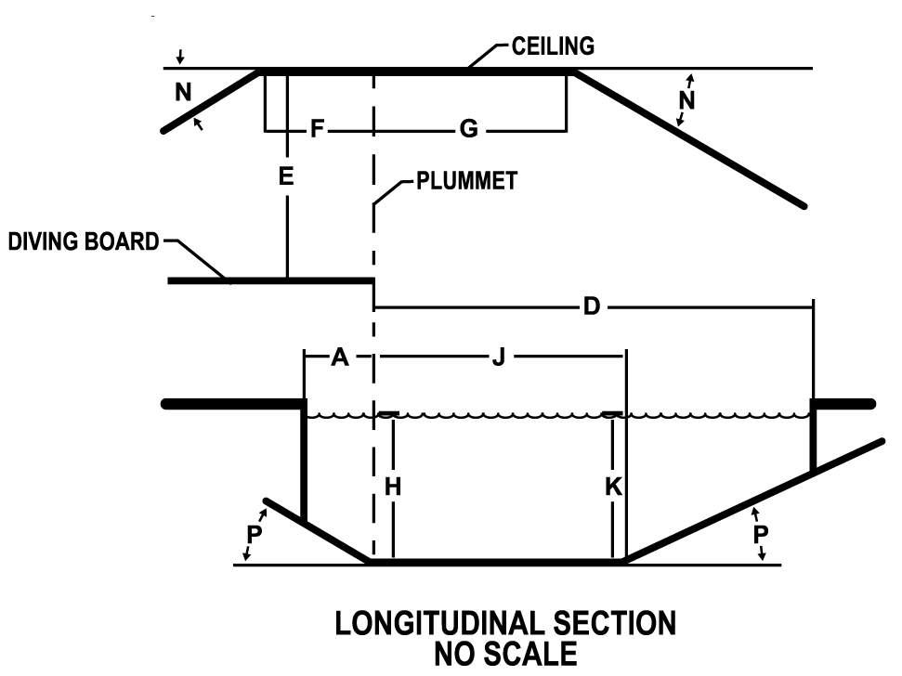
Figure 408020.4 Diving Platform Cross-section: Front View
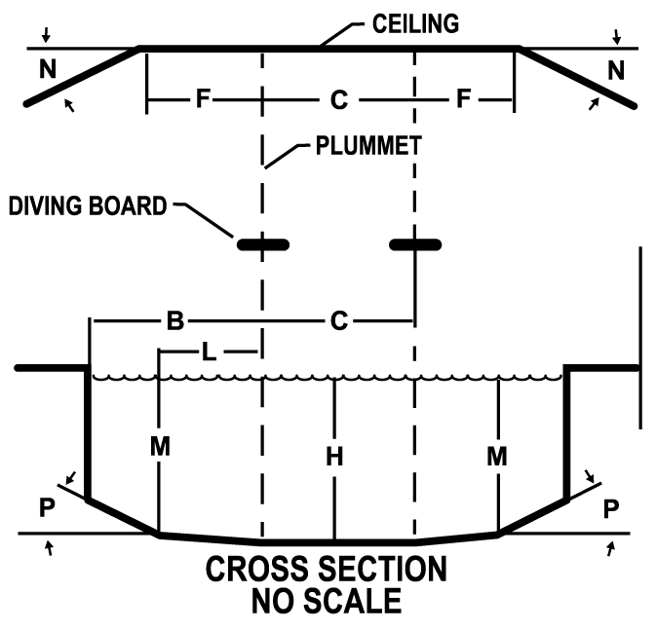

WAC 246-261-408030 Starting platforms (2023 MAHC 4.8.3)
(1) Conform to standard codes. Starting platforms shall be installed and conform to applicable SAFETY STANDARDS established by:
(a) FINA;
(b) U.S.A. Swimming;
(c) NCAA;
(d) NFHS;
(e) YMCA; or
(f) Other sanctioning body.
(2) Minimum water depth. Starting platforms shall be installed in a minimum water depth of four feet (1.25 m), except for new construction, where starting platforms shall be installed in a minimum water depth of six feet (1.8 m).
(3) Leading edge. The leading edge of starting platforms shall have a maximum height of 30 inches (76.2 cm) above the water surface.
(4) Slip resistant. Starting platforms shall have SLIP-RESISTANT tread surfaces.
(5) Secure and stable. Starting platforms shall be installed and secured per manufacturer's recommendations at all times when in use.
WAC 246-261-408050 Lifeguard—Safety-related equipment (2023 MAHC 4.8.5)
(1) Safety equipment required at all aquatic facilities.
(a) Emergency communication equipment. The AQUATIC FACILITY or each AQUATIC VENUE, as necessary, shall have a functional telephone or other communication device that is hard wired and capable of directly dialing 911 or function as the emergency notification system.
(b) Conspicuous and accessible. The telephone or communication system or device must be conspicuously provided and accessible within the AQUATIC VENUE ENCLOSURE and no more than 100 feet walking distance of each AQUATIC VENUE.
(c) Alternate communication systems. Alternate systems, devices, or communication processes are allowed with approval of the AHJ in situations when a telephone is not logistically sound, and an alternate means of communication is available, which meet the requirements of WAC 246-261-50805X.
(d) Internal communication. The AQUATIC FACILITY design shall include a method for staff to communicate in cases of emergency.
(e) Signage. A sign shall be posted at the telephone providing dialing instructions, address and location of the AQUATIC VENUE location, and the telephone number.
(2) Safety equipment required at facilities with lifeguards.
(a) Lifeguard chair and stand placement. The designer shall coordinate with the owner and/or an aquatic consultant to consider the impact on BATHER surveillance zones for placement of chairs and stands designed to be permanently installed so as to provide an unobstructed view of the BATHER surveillance zones.
(b) Lifeguard chair and stand design. The chairs/stands shall be designed:
(i) With no sharp edges or protrusions;
(ii) With sturdy, durable, and UV–resistant materials;
(iii) To provide enough height to elevate the lifeguard to an eye level above the heads of the BATHERS; and
(iv) To provide safe access and egress for the lifeguard.
(c) UV protection for chairs and stands. Where provided, permanently installed chairs/stands, where QUALIFIED LIFEGUARDS can be exposed to UV radiation, shall include protection from such UV radiation exposure.
WAC 246-261-408060 Barriers and enclosures (2023 MAHC 4.8.6)
(1) General requirements.
(a) Enclosure. All AQUATIC FACILITIES, CHEMICAL STORAGE SPACES, and AQUATIC VENUE mechanical spaces shall be located in an ENCLOSURE to prevent unauthorized entry.
(b) Enclosures. The ENCLOSURE may consist of any combination of building envelopes, site walls, or fencing as provided for in this section.
(c) Patron accessibility. An ENCLOSURE shall be provided between CHEMICAL STORAGE SPACES, POOL, mechanical spaces, and areas accessible to the public, in accordance with applicable local, state, territorial, federal, and tribal building CODES.
(2) Construction requirements.
(a) Discourage climbing. BARRIERS or ENCLOSURES shall discourage climbing by providing a 3-foot clearance to nearby structures to simplify climbing over it, such as: Light poles, site furnishings, overhanging tree limbs, or other obvious footholds or handholds.
(b) Horizontal members. Where the ENCLOSURE is composed of horizontal and vertical members:
(i) Horizontal members shall be located on the AQUATIC VENUE side of the ENCLOSURE.
(ii) Where there are decorative cutouts within vertical members, spacing within the cutouts shall not exceed 1 3/4 inches (44 mm) in width.
(iii) When the distance between the tops of the horizontal members is less than 45 inches (1143 mm), spacing between vertical members shall not exceed 1 3/4 inches (44 mm) in width.
(iv) When the distance between the tops of the horizontal members is 45 inches (1143 mm) or more, spacing between vertical members shall not exceed four inches (102 mm) and prevent the passage of a four-inch diameter sphere with the application of 50 pounds of force.
Figure 408060.1 Horizontal members less than 45"
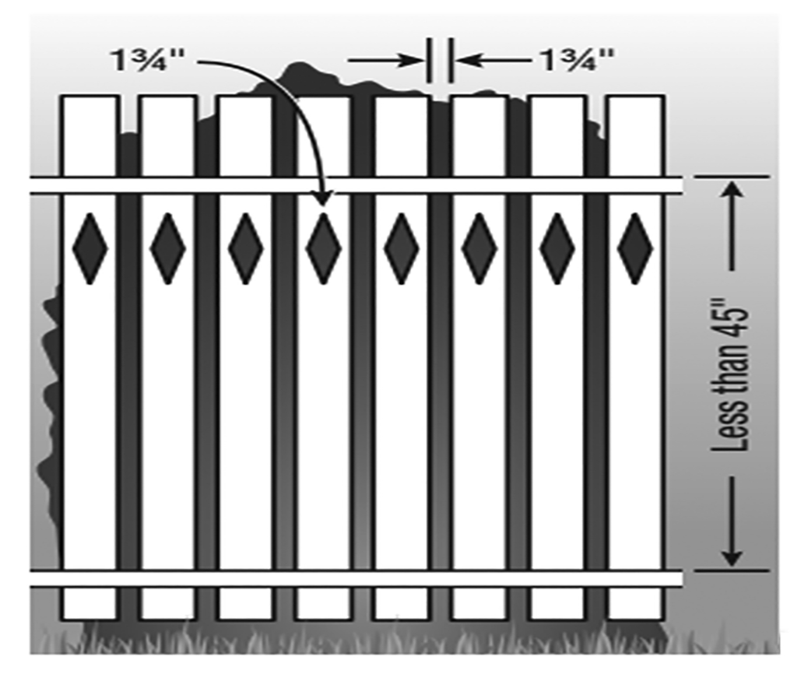

Figure 408060.2 Horizontal members greater than 45"
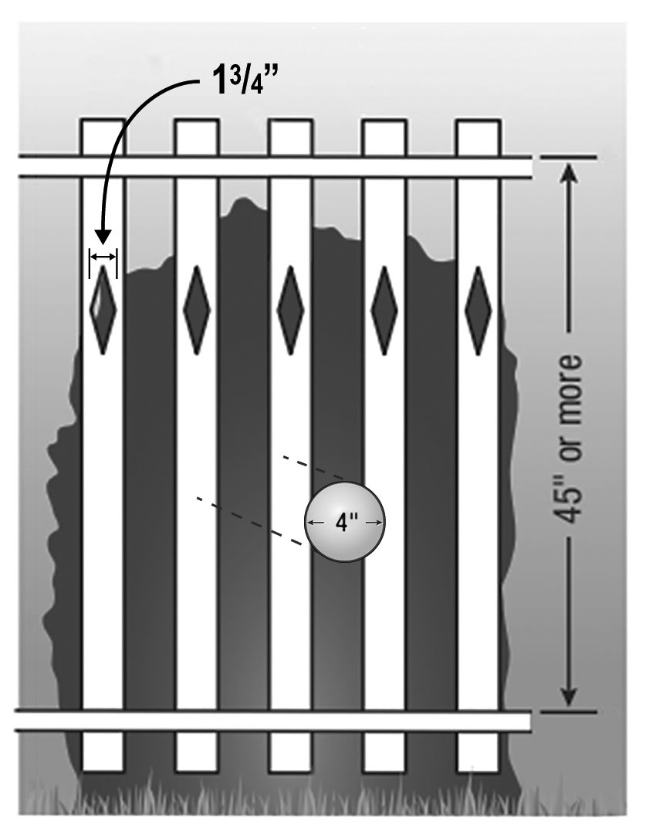
(c) Mesh fencing. The mesh size for chain-link fencing may not exceed 1 1/4 inches (31.7 mm) unless slats, fastened at the top or bottom of the fence, are used to reduce the mesh openings to no more than 1 3/4 inches (44.4 mm).
Figure 408060.3 Mesh fencing
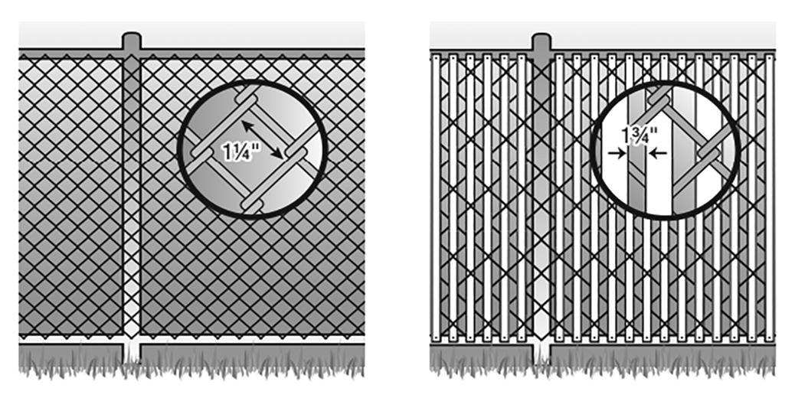
(d) Solid surfaces. Where the enclosure is composed of a solid surface, such as masonry or stone walls, no indentations or protrusions shall be present, other than normal construction tolerances and masonry joints. Such indentations shall not be deeper than 0.375 inches (10 mm).
Figure 408060.4 Solid surfaces
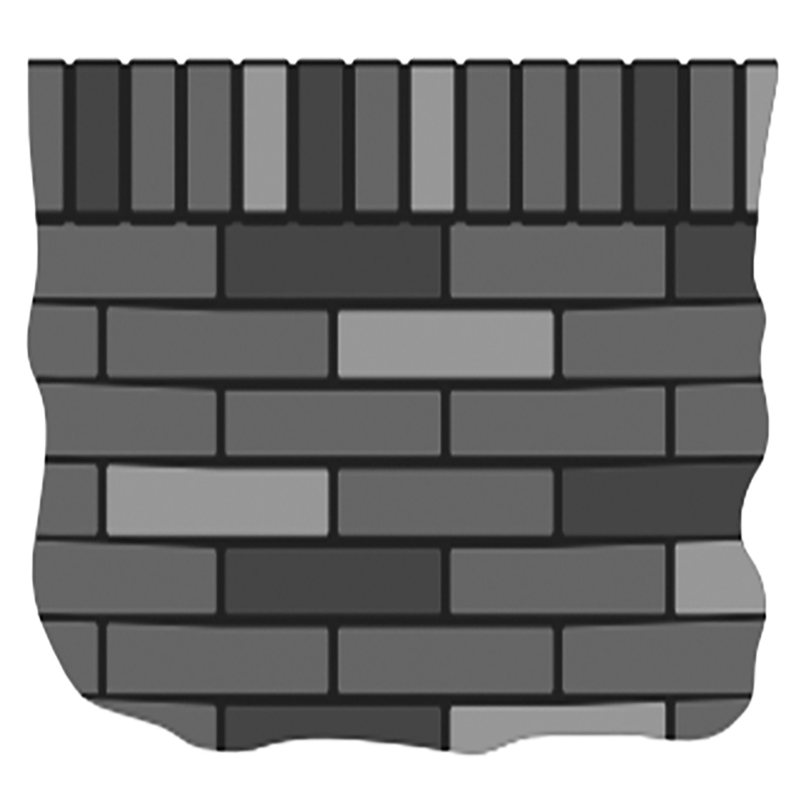
(e) Emergency exit paths. ENCLOSURES for AQUATIC VENUES shall not block or encumber a required emergency egress path from other structures, nor shall emergency egress from other structures not a part of the AQUATIC FACILITY lead into or access an ENCLOSURE for an AQUATIC VENUE.
(f) Windows. Windows having a sill height of less than 72 inches above the pool deck on a building that forms part of an ENCLOSURE around an AQUATIC VENUE shall have a maximum opening width not to exceed four inches (102 mm) and prevent passage of a four-inch diameter sphere with the application of 50 pounds of force. If designed to be opened, windows shall also be provided with a nonremovable screen. A building wall that forms part of an ENCLOSURE around an AQUATIC VENUE shall not have living units on the interior of the ENCLOSURE wall.
(g) Openings. Openings in a BARRIER or ENCLOSURE must not allow the passage of a four-inch diameter sphere with the application of 50 pounds of force.
Figure 408060.5 Openings
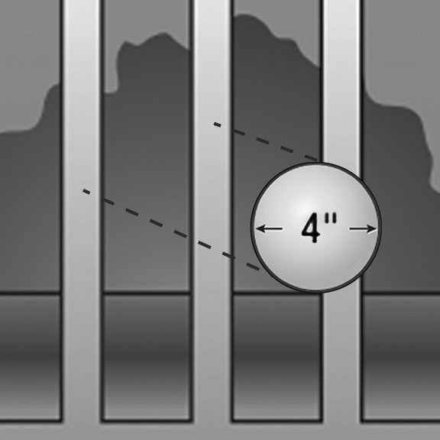
(h) Height. ENCLOSURES shall be no less than six feet (1.83 m) in height.
(i) Change in grade. Where a change in grade occurs at an ENCLOSURE, height shall be measured from the uppermost grade to the top of the ENCLOSURE.
(ii) Fencing requirements. Height shall be measured from the finished grade to the top of the ENCLOSURE on the side outside of the ENCLOSURE surrounding an AQUATIC VENUE.
(iii) Other barriers not serving as part of an enclosure. Except where otherwise noted, all other BARRIERS not serving as part of an AQUATIC FACILITY ENCLOSURE shall not be less than 42 inches (1.1 m) in height.
(i) Clearance above grade. The maximum vertical clearance at the bottom of the AQUATIC VENUE or AQUATIC FACILITY ENCLOSURE when measured on the side of the ENCLOSURE facing away from the enclosed space, shall not exceed:
(i) Two inches (5.1 cm) above grade when the ENCLOSURE rests on a nonsolid surface, including grass or gravel; or
(ii) Four inches (10.2 cm) above grade and prevents the passage of a four-inch diameter sphere when the ENCLOSURE rests on a solid surface.
Figure 408060.6 Clearance above grade
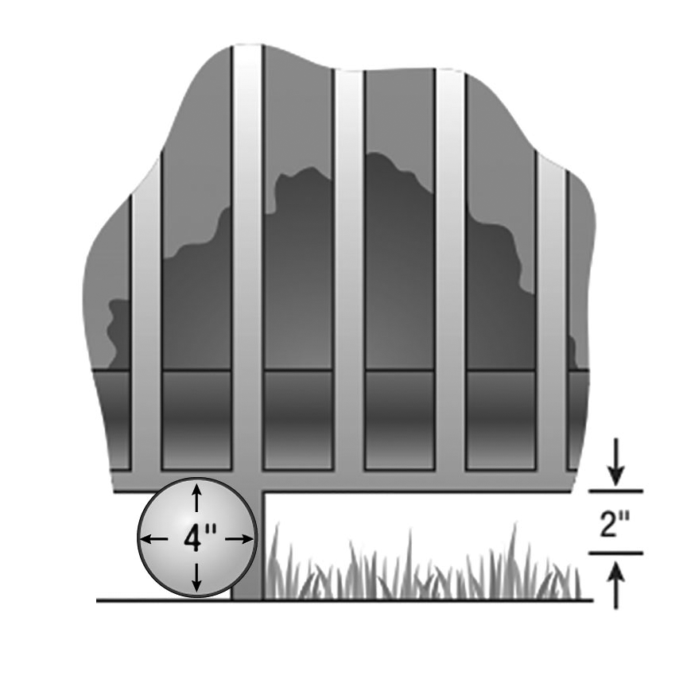
(3) Gates and doors. All gates and doors serving as part of an AQUATIC FACILITY or AQUATIC VENUE are subject to the following:
(a) Self-closing and latching. All public access gates or doors serving as part of an AQUATIC FACILITY ENCLOSURE or AQUATIC VENUE ENCLOSURE shall be self-closing and self-latching from any open position.
(b) Accessible routes. All public access gates or doors serving as part of an AQUATIC FACILITY or AQUATIC VENUE ENCLOSURE and an ACCESSIBLE ROUTE shall be the self-locking type such as where the lock is operated by means of a key, electronic opener, or the entry of a combination into an integral combination lock.
(c) Release latch height and locking requirements. Operable parts of the release latch on:
(i) Self-latching devices that self-lock, the lock operation control and the latch release shall be located not less than 34 inches and not greater than 48 inches above finished grade; and
(ii) Self-latching devices that do not self-lock shall be located a minimum of 60 inches above finished grade from the bottom of the latch release.
(d) Inoperable by children. Self-latching devices shall not be operable by small children on the outside of the ENCLOSURE around the AQUATIC VENUE. A BARRIER is required around a latch less than 60 inches high to prevent activating the latch from outside the ENCLOSURE. The BARRIER must have a minimum 18 inch radius of material around the latch and the material shall not have any openings that exceed 1/2 inch in any dimension.
Figure 408060.7 Inoperable by children
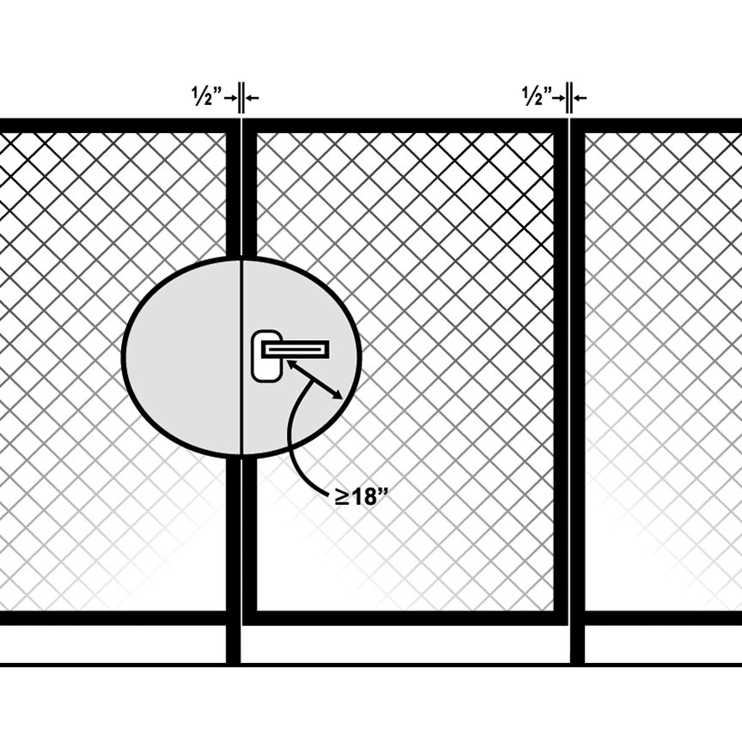
(e) Self-locking device. Self-locking devices must latch and lock automatically when the door or gate returns to a closed position.
(f) Locked. All gates or doors shall be capable of being locked from the exterior.
(g) Emergency egress. Gates or doors shall be designed in such a way that they do not prevent egress in the event of an emergency.
(h) Unauthorized entry. EXIT GATES or doors shall be constructed so as to prevent unauthorized entry from outside of the ENCLOSURE around the AQUATIC VENUE.
(i) Exceptions. The requirements of (a) through (h) of this subsection do not apply when the gate or door of an AQUATIC FACILITY or AQUATIC VENUE ENCLOSURE is part of the AQUATIC VENUE(S) and has a QUALIFIED LIFEGUARD(S) conducting PATRON surveillance at all times, the AQUATIC VENUE(S) is open and the gate or door is locked at all times, the AQUATIC FACILITY or AQUATIC VENUE is not open to the public.
(j) Gates. Gates shall be at least equal in height at top and bottom to the ENCLOSURE of which they are a component.
(k) Turnstiles. Turnstiles shall not form a part of an AQUATIC FACILITY ENCLOSURE.
(l) Exit gates. EXIT GATES shall be conspicuously marked on the inside of the AQUATIC VENUE or AQUATIC FACILITY.
(i) Quantity, location, and width. Quantity, location, and width(s) for EXIT GATES shall be provided consistent with all applicable local, state, territorial, federal, and tribal building and fire CODES and applicable accessibility guidelines.
(ii) Swing outward. EXIT GATES shall swing away from the AQUATIC VENUE ENCLOSURE.
(iii) Absence of building codes. Where local, state, territorial, federal, and tribal building CODES do not otherwise govern, at least one 36-inch (91.4 cm) wide EXIT GATE shall be required for emergency access to each logical AQUATIC VENUE area including individual POOLS or grade levels or both.
(4) Indoor aquatic venues.
(a) Enclosure. Building walls enclosing an INDOOR AQUATIC FACILITY may be designated as the AQUATIC FACILITY ENCLOSURE.
(b) Securable. Indoor AQUATIC VENUES shall be securable from unauthorized entry from other building areas or the exterior.
(c) Indoor and outdoor aquatic venues. Where separate indoor and outdoor AQUATIC VENUES are located on the same site, an AQUATIC VENUE ENCLOSURE shall be provided between them except where all AQUATIC VENUES are operated continuously 12 months a year on the same schedule.
(d) Wall separating. For a passage through a wall separating the indoor portion of an AQUATIC VENUE from an outdoor portion of the same AQUATIC VENUE, the overhead clearance of the passage to the AQUATIC VENUE floor shall be at least six feet eight inches (2.0 m) to any solid structure overhead.
(5) Multiple aquatic venues.
(a) One enclosure. Except as otherwise required in this chapter, one ENCLOSURE may surround multiple AQUATIC VENUES at one facility.
(b) Wading pools. WADING POOLS shall not require separation from other WADING POOLS by a BARRIER. Refer to WAC 246-261-4012XX for additional guidance about WADING POOLS.
WAC 246-261-408070 Aquatic venue cleaning systems (2023 MAHC 4.8.7)
(1) No hazard. The cleaning system provided shall not create an entanglement or suction entrapment hazard or interfere with the operation or use of the AQUATIC VENUE.
(2) Integral vacuum systems. Use of integral vacuum systems, meaning a vacuum system that uses the main circulating pump or a dedicated vacuum pump connect to the POOL with PVC piping and terminating at the POOL with a flush-mounted vacuum port fitting, shall be prohibited.

