DOH 342-034 JAN 2025



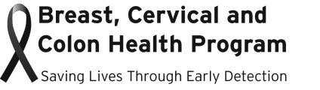

**INCOME ELIGIBILITY TABLES**

**Effective January 17, 2025 – January 31, 2026**

These tables determine income eligibility for the Breast, Cervical and Colon Health Program based on Federal Poverty Level (FPL):

|  |  |  |
| --- | --- | --- |
| **Gross Yearly Income** | | |
| **Family Size** | **250% FPL** | **300% FPL** |
| 1 | $39,125 | $46,950 |
| 2 | $52,875 | $63,450 |
| 3 | $66,625 | $79,950 |
| 4 | $80,375 | $96,450 |
| 5 | $94,125 | $112,950 |
| 6 | $107,875 | $129,450 |
| 7 | $121,625 | $145,950 |
| 8 | $135,375 | $162,450 |
| 8+  Add per each additional member | $13,750 | $16,500 |

|  |  |  |
| --- | --- | --- |
| **Gross Monthly Income** | | |
| **Family Size** | **250% FPL** | **300% FPL** |
| 1 | $3,260 | $3,913 |
| 2 | $4,406 | $5,288 |
| 3 | $5,552 | $6,663 |
| 4 | $6,698 | $8,038 |
| 5 | $7,844 | $9,413 |
| 6 | $8,990 | $10,788 |
| 7 | $10,135 | $12,163 |
| 8 | $11,281 | $13,538 |
| 8+  Add per each additional member | $1,146 | $1,375 |