Chapter 246-314 WAC
Construction
Review Services
Based on the rules last updated
06/15/2012
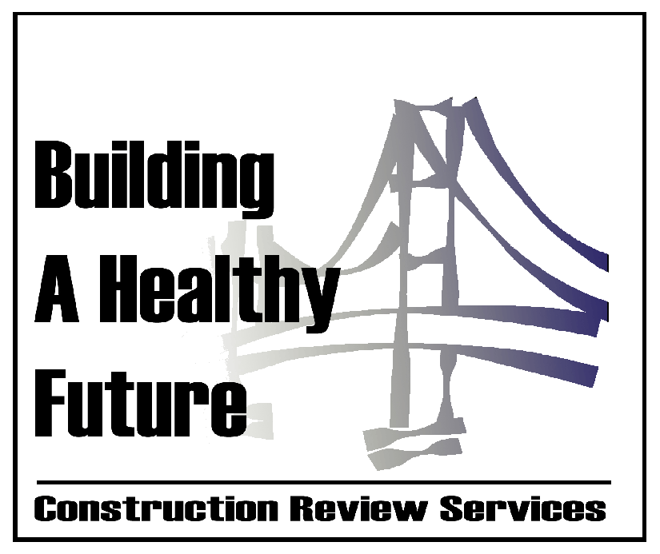
Washington State Department of Health
Construction Review Services
111 Israel Rd SE
Tumwater, WA 98501
PO Box 47852
Olympia, WA 98504
www.doh.wa.gov/crs
tel. 360-236-2944

Table of Contents

Table of Contents 3
246-314-001 Purpose. 4
246-314-010 Definitions. 4
246-314-015 Application requirements. 5
246-314-990 Construction review fees. 5

246-314-001 Purpose.
The purpose of this chapter is to establish fees to support the department's predesign, subsequent review, approval activities, and to enable the department to provide technical assistance for health and residential care facility construction projects.

246-314-010 Definitions.
The definitions in this section apply throughout this chapter unless the context clearly indicates otherwise:
- "Certified" means facilities that must be certified to participate in medicare or medicaid programs and meet physical environment minimum standards as required in the Code of Federal Regulations.
- "Change of approved use only" means a change in the function of a room that does not alter the physical elements.
- "Finishes" includes, but is not limited to, products such as carpet, vinyl wall covering, wall paper, exterior siding, landscaping, or paneling applied to an existing surface as the exposed surface.
- "Licensed" means facilities licensed from the state department of health (DOH) or state department of social and health services (DSHS) that must obtain approval from construction review services before licensure activity.
- "Permit" means a recommendation to the licensing or certifying authority from construction review services indicating that a facility meets the physical environment rules and the plan review process is complete.
- "Program" means the Washington state department of health, construction review services.
- "Project" means a change to a facility including new construction, replacement, alterations, additions, expansions, conversions, change of approved use, improvements, remodeling, renovating, and upgrading of the following types of facilities:
  - "Ambulatory surgery center" defined as a facility that is required to be certified for participation in medicare or medicaid or ambulatory surgical facilities licensed under chapters 70.230 RCW and 246-330 WAC;
  - "Birthing centers" (formerly maternity homes) and "childbirth centers" licensed under chapters 18.46 RCW and 246-329 WAC;
  - "Boarding homes" licensed under chapters 18.20 RCW and 388-78A WAC;
  - "Correctional facilities" as defined under RCW 43.70.130(8);
  - "Hospice care center" licensed under chapters 70.127 RCW and 246-335 WAC;
  - "Hospitals" licensed under chapters 70.41 RCW and 246-320 WAC;
  - "Nursing homes" licensed under chapters 18.51 RCW and 388-97 WAC;
  - "Private alcohol and chemical dependency hospitals" licensed under chapters 71.12 RCW and 246-324 WAC;
  - "Private psychiatric and alcoholism hospitals" licensed under chapters 71.12 RCW and 246-322 WAC;
  - "Residential treatment facilities" licensed under chapters 71.12 RCW and 246-337 WAC; and
  - "Temporary worker housing" licensed under chapters 70.114A RCW and 246-358 WAC.
- "Project cost" means all costs directly associated with the project, initially estimated and corrected by certification to the date of completion of the project and including all fixed and installed clinical equipment in the project and contractor supervision, inspection, and overhead. This cost does not include:
  - Taxes;
  - Architectural or engineering fees; and
  - Land acquisition fees.
- "Project sponsor" means the person, persons or organization, planning and contracting for the design and construction of facilities, generally the owner or the owner's representative.
- "Technical assistance” means assistance provided by the program to facilities either at the program offices or at the project location including:
  - Information on the laws, rules and compliance methods and technologies applicable to the regulations;
  - Information on methods to avoid compliance problems;
  - Assistance in applying for permits, licensure or certification;
  - Information on the mission, goals, and objectives of the program; and
  - Assistance to parties constructing projects not required to be licensed or certified and voluntarily wish to comply with rules or guidelines in the interest of safety or best practices.
- "Value of existing construction" means the value of an existing building or portion thereof at the time of project submission, based on the current market value of the structure as documented by the project sponsor, or, as determined by assigning a cost per square foot value.

246-314-015 Application requirements.
The project sponsor shall submit to the program:
- An estimated permit value at the time of application. Permit valuations include the total value of work, including materials and labor, such as electrical, gas, mechanical, plumbing equipment and permanent systems. If the program determines the valuation is underestimated, the program shall deny the application unless the applicant can show detailed estimates to meet the program's approval. Final building permit valuation is set by program;
- A completed project review application form with project documents for review;
- Documentation as required by the applicable licensing or certification rules; and
- The appropriate fee based upon the initial project construction cost as determined from the construction fee table in WAC 246-314-990.

246-314-990 Construction review fees.
- Upon prior approval by the program the project sponsor may exclude from the "project cost" the cost for fixed or installed technologically advanced clinical equipment such as but not limited to: Lithotripters, CT scans, linear accelerators, and MRIs.
- Project fee table. Except as provided in subsection (4) and (5) of this section, the following fees will be charged for project review based on the cost of the project:
Project Cost |  |  | Project Review Fee
$0 | to | $999 | $150
$1,000 | to | $1,999 | $305
$2,000 | to | $2,999 | $400
$3,000 | to | $4,999 | $500
$5,000 | to | $9,999 | $650
$10,000 | to | $19,999 | $815
$20,000 | to | $29,999 | $1,000
$30,000 | to | $39,999 | $1,190
$40,000 | to | $49,999 | $1,375
$50,000 | to | $64,999 | $1,620
$65,000 | to | $79,999 | $1,875
$80,000 | to | $99,999 | $2,250
$100,000 | to | $124,999 | $2,690
$125,000 | to | $149,999 | $3,120
$150,000 | to | $199,999 | $3,625
$200,000 | to | $249,999 | $4,060
$250,000 | to | $324,999 | $4,455
$325,000 | to | $449,999 | $5,000
$450,000 | to | $574,999 | $5,615
$575,000 | to | $699,999 | $6,350
$700,000 | to | $849,999 | $7,110
$850,000 | to | $999,999 | $7,995
$1,000,000 | to | $1,249,999 | $8,725
$1,250,000 | to | $2,499,999 | $9,560
$2,500,000 | to | $2,999,999 | $10,430
$3,000,000 | to | $3,499,999 | $11,350
$3,500,000 | to | $4,999,999 | $13,115
$5,000,000 | to | $6,999,999 | $14,885
$7,000,000 | to | $9,999,999 | $16,840
$10,000,000 | to | $14,999,999 | $19,340
$15,000,000 | to | $19,999,999 | $21,780
$20,000,000 | to | $29,999,999 | $24,280
$30,000,000 | to | $39,999,999 | $28,060
$40,000,000 | to | $59,999,999 | $31,235
$60,000,000 | and over |  | $31,235 plus 0.05%  per dollar above 60 million

- Existing building conversions. Building conversion fees will be based on the value of existing construction. Fees will be charged for project review based on the project fee table in subsection (2) of this section.
  - The existing construction value is based on the local area cost data.
  - Current cost data is available and posted on the construction review services web site: http://www.doh.wa.gov/crs.
  - Project sponsors may submit specific cost data that accurately describes the estimate good faith value for the program's consideration
- Flat fees. The following projects will receive a discount on project review fees:
- Installation of finishes only, one hundred fifty dollars;
- Change of approved use only, one hundred fifty dollars;
- The first submission for review and approval of the site installation of a mobile unit, five hundred seventy-five dollars. Each additional submission of the same project, two hundred eighty-five dollars;
- The first submission for review and approval of the equipment supplier of a mobile unit, five hundred seventy-five dollars. Each additional submission of the same project, two hundred eighty-five dollars;
- Each eight staff hours or fraction thereof for technical assistance, five hundred dollars. For technical assistance requiring travel, the program may increase the fee to include travel expenses;
- Special projects as determined by the program that requires minimal or highly repetitive review, five hundred dollars for every review or inspection after the initial review;
- Plan review and inspection for the on-site installation of the foundation, and hook-ups including, but not limited to, potable water, sewage disposal systems, or gas connections for factory assembled structures, two hundred fifty dollars per site visit regardless of the number of sites installed and completed at the time of inspection;
- On-site inspection and plan review for foundation pad for temporary structures including, but not limited to, tents and RVs, one hundred and twenty dollars per site visit regardless of the number of pads installed and completed at the time of inspection.
- Fee reductions. The program may decrease the project review fees, when:
  - The project sponsor requests a reduction in the fee according to subsection (1) of this section;
  - The project is prepared by a state licensed architect or engineer when architectural or engineering services are not required by rule. The project may qualify for a reduction of up to fifteen percent;
  - A facility is converted from another occupancy as defined by the state building code; a facility is converted from one license to another; or, a facility that is currently unlicensed, but was previously licensed through the Washington state department of health or the Washington state department of social and health services, wishes to be reviewed for relicensure. The project may qualify for a reduction of up to fifty percent. The amount of fee reduction will be determined by the estimated amount of systems review required to ensure that the rules have been met.
- Total fee reductions may not exceed seventy percent of the original estimated project review fee.
- Refunds. The program shall refund fees paid when requested by the applicant as follows:
  - The final attested project cost is less than the project estimated on the application. Fees paid may be refunded by the program according to the project fee table in subsection (2) of this section.
  - If a project is canceled after an application and fee has been received but no plan review or technical assistance has been performed by the program, seventy-five percent of the fees paid.
  - If a project is canceled after an application and fee has been received and plan review or technical assistance has been performed by the department, fifty percent of the fees paid.
- No fees paid by the applicant will be refunded after project cancellation if any of the following applies:
  - More than two on-site visits, conferences, or plan reviews for any purpose have been performed by the program;
  - One year has elapsed since an application and fee is received by the program, but no permit is issued because applicant failed to complete requirements for permit, and the applicant has not pursued the project in good faith;
  - The amount to be refunded as calculated by subsection (7)(a), (b), or (c) of this section is one hundred twenty dollars or less;
  - Approval or authorization to begin construction or a permit has been issued or construction has begun prior to a request from the applicant to cancel the project; or with
  - A written request has not been receive to cancel the project.

