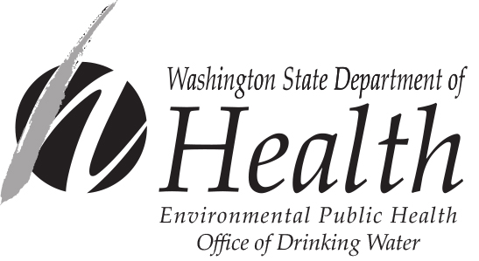
Engineering Design Review Report
(For Distribution-Related Project Submittal Exceptions)

In accordance with WAC 246-290-125(3), an Engineering Design Review Report form must be completed for each distribution-related project (other than new distribution mains) constructed per the submittal exception process. The form must be completed prior to the construction of the project. Purveyors must maintain the form on file and submit it to the Department of Health (DOH) when requested. Furthermore, in accordance with WAC 246-290-125(3)(e)(vii)(A), the form must bear the seal, date, and signature of a professional engineer (PE) licensed in the state of Washington prior to the start of construction of the project.

In accordance with WAC 246-290-125(2), this form is not required for distribution main projects constructed according to a current, DOH-approved, water system plan that includes standard construction specifications for distribution mains.

Please type or print legibly in ink: DOH Water System ID No.: _________

Name of Water System Name of Engineering Design Firm*

Name of Purveyor (Owner or System Contact) Name of PE on Design Documents

Mailing Address Mailing Address*

City State Zip City State Zip*

Type of Project (check all that apply):
Booster Pump Stations
Pressure Tanks Name of Engineering Review Firm*
Reservoirs and Storage Tanks
Transmission Mains Name of PE Performing Design Review*
Other (specify):
Mailing Address*

City State Zip*

* Complete only if the professional engineer is not employed directly by the water system. NOTE: The design engineer and review engineer may both be employed directly by the water system or work for the same engineering firm, but the same engineer may not be responsible for both the design and review responsibilities.
NOTE: In accordance with WAC 246-290-125(4), source-of-supply projects, including interties, and water quality treatment projects are not eligible for the submittal exception process. Project reports and construction documents for these types of projects must be submitted to DOH for review and approval in accordance with chapter 246-290 WAC.
Also, for new storage tanks and booster pump stations, a Construction Completion Report must be submitted to the department in accordance with WAC 246-290-125(3)(f). Construction Completion Reports for other distribution-related projects requiring engineering design, and completed under the submittal exception process, must be on file with the water system in accordance with WAC 246-290-125(2)(b) and -125(3)(f).

A DOH project checklist may assist you in your review of project reports and/or construction documents. Checklists are available from the regional office in your area (see page 2).

Engineering Design Review Report Form (continued)
Proposed Project Name and Descriptive Title:

Reviewing Engineer’s Comments (Per WAC 246-290-125(3)(e)(vii)(B), provide a descriptive reference to the completed project report or construction documents reviewed):
(Attach additional sheets as necessary)

Professional Engineer’s Acknowledgment

The undersigned professional engineer (PE), or their authorized agent, has reviewed the project report or construction documents for the above-described proposed project. The project’s design documents bear the seal and dated signature of the design engineer identified above. In the opinion of the undersigned engineer the design is in accordance with both the DOH regulations and appropriate principles of standard engineering practice.

Review Engineer’s Signature
PE’s Seal

Date Signed

The water system purveyor is to retain this completed form on file and make it available to DOH upon request. For additional information please contact one of the DOH Drinking Water regional offices identified below.
Northwest Drinking Water  Department of Health  PO Box 47800  Olympia WA 98504  Phone: 253-395-6750  Fax: 253-395-6760 | Southwest Drinking Water  Department of Health  PO Box 47823  Olympia, WA 98504-7823  Phone: 360-236-3030  Fax: 360-664-8058 | Eastern Drinking Water  Department of Health  16201 E Indiana Ave, Suite 1500  Spokane Valley, WA 99216  Phone: 509-329-2100  Fax: 509-329-2104
For people with disabilities, this document is available on request in other formats. To submit a request, please call 1-800-525-0127 (TDD/TTY call 711).

