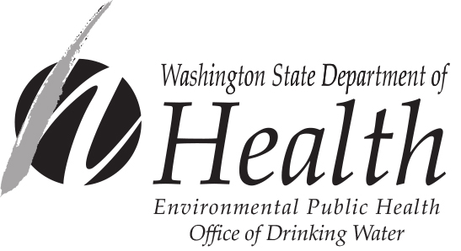

Potential GWI Source

Identification and Designation Form

Any drinking water professional (or contract representative) from a public health jurisdiction (local health jurisdiction or state drinking water program) may formally identify to the state a potential GWI source, if they find a drinking water source that meets the potential GWI identification criteria given below. A professional engineer or hydrogeologist, with experience in the state drinking water programs and the GWI program, may designate a potential GWI source. A source must be designated a potential GWI source before it can be initiated into the GWI program and evaluated under the GWI determination process.

Potential GWI Identification Criteria

Please circle criteria below that apply to the identification and designation of this potential GWI source.

- A well with an open interval of 50 feet or less below the ground surface at the wellhead, also located within two hundred feet of surface water.
- Ranney well.
- Infiltration gallery.
- A spring or springs.
- A hand pump not meeting minimum construction standards outlined in WAC 173-160.
- A dug well not meeting minimum construction standards outlined in WAC 173-160.
- A sand point (well point) not meeting minimum construction standards outlined in WAC 173-160.
- Well located within 200 feet of surface water that lacks construction documentation.
- Other: ________________________________________________________________

Potential GWI Identification and Designation Data

Water System Name: ____________________________________________________________
Water System ID: _______________________________________________________________
Source Name: __________________________________________________________________
Source ID #: ___________________________________________________________________
Well Tag #: ____________________________________________________________________

General description of source [Include size, type, depth (to screen, bottom, pump, static water level), construction details, well log (if available), a cross-sectional drawing or sketch, if available, etc.]: _________________________________________________________________ ________________________________________________________________________________________________________________________________________________________________________________________________________________________________________________________________________________________________________________________

General description of the Sanitary Control Area (SCA) within 200 feet of the source [Include a plan-view map or aerial photograph of the general area, if available]: ______________________ ________________________________________________________________________________________________________________________________________________________________________________________________________________________________________________________________________________________________________________________

Identifier or designator comments: _________________________________________________ ________________________________________________________________________________________________________________________________________________________________________________________________________________________________________________________________________________________________________________________

Potential GWI source identifier’s name and title (print): ________________________________
Potential GWI source identifier’s signature: __________________________________________
Date of signature: _______________________________________________________________

Potential GWI source designator’s name and title (print): ______________________________
Potential GWI source designator’s signature: ________________________________________
Date of signature: _______________________________________________________________

Return completed form to your local regional office:

Northwest Regional Office:  20425 72nd Ave. S., Suite 310  Kent WA 98032  Main Office: 253-395-6750  Fax: 253-395-6760  Area of Coverage: Island, King, Pierce, San Juan, Skagit, Snohomish, and Whatcom Counties | Southwest Regional Office:  243 Israel Road SE, Tumwater  PO Box 47823, Olympia WA 98504  Main Office: 360-236-3030  Fax: 360-664-8058  Area of Coverage: Clallam, Clark, Cowlitz, Grays Harbor, Jefferson, Kitsap, Lewis, Mason, Pacific, Skamania, Thurston, and Wahkiakum Counties. | Eastern Regional Office:  16201 E. Indiana Ave., Suite 1500 Spokane Valley WA 99216  Main Office: 509-329-2100  Fax: 509-329-2104  Area of Coverage: Adams, Asotin, Benton, Chelan, Columbia, Douglas, Ferry, Franklin, Garfield, Grant, Kittitas, Klickitat, Lincoln, Okanogan, Pend Oreille, Spokane, Stevens, Walla Walla, Whitman, and Yakima Counties.

For people with disabilities, this document is available on request in other formats. To submit a request, please call 1-800-525-0127 (TDD/TTY call 711).

