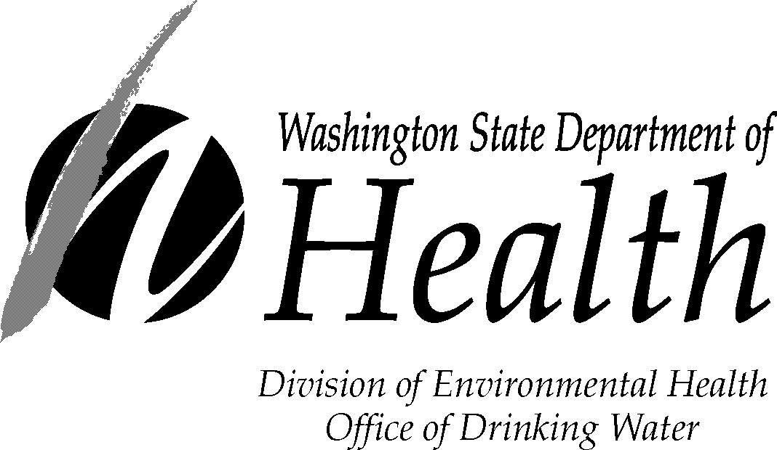

GWI DETERMINATION PROCESS
PURVEYOR’S CHOICE FORM

Within 30 days of receipt of this letter, complete and return this form to:
GWI Program Lead, Department of Health, Office of Drinking Water
P.O. Box 47822, Olympia, WA 98504-7822

Please indicate the GWI determination process option you have decided to implement. Based on your choice, the department will meet with you and prepare a plan tailored to meet your site-specific circumstances.
- I will inactivate my potential GWI source.

2) I will reconstruct my potential GWI source.

3) I will evaluate my potential GWI source for Hydraulic Connection with Surface Water using the Hydrogeologic Assessment Method.

4) I will evaluate my potential GWI source for Hydraulic Connection with Surface Water using the Water Quality Monitoring Method.

5) I accept a designation of Hydraulic Connection with Surface Water, will install disinfection per WAC 246-290 and continue in the GWI determination process using the Microscopic Particulate Analysis (MPA) Method.

- I accept a designation of GWI and a referral to the Surface Water Source Program staff for assistance with complying with the Surface Water Treatment Rule requirements.

Water System Name: ____________________________________________________________
Water System ID: _______________________________________________________________
Source ID#: ____________________________________________________________________
Source Name: __________________________________________________________________
Well Tag #: ____________________________________________________________________

Owner or Manager’s Name (print):_________________________________________________
Owner or Manager’s Signature:____________________________________________________
Date of Signature:_______________________________________________________________

GWI DETERMINATION PROCESS
PURVEYOR OPTIONS

This information pertains to water system sources that have been designated as a “potential GWI source.” GWI is an abbreviation for “groundwater under the direct influence of surface water.” This information describes the options a purveyor has to complete the GWI determination process; that is, the process to determine whether a source is groundwater (and is subject to groundwater source monitoring and treatment requirements) or GWI (and subject to the Surface Water Treatment Rule requirements).

(Note that a potential GWI source can be inactivated or modified at any time during the GWI determination process.)

1) Inactivate the Potential GWI Source

If you choose the option of inactivating your potential GWI source, it must be placed in emergency status (physically disconnected from the distribution system) or inactivated (properly decommissioned). As long as this source remains on emergency or inactive status, the GWI determination process is suspended. If at any time in the future, you wish to reactivate the potential GWI source (and classify it as active permanent or seasonal use), the source will again be required to complete the GWI determination process in affect at that time.

2) Modify the Potential GWI Source

If you choose the option of modifying your potential GWI source (e.g., through reconstruction), it must first be placed in emergency status (physically disconnected) and not used until modifications are complete and approved by the department. As long as your source remains on emergency status, the GWI determination process is suspended.

A source modification project must be prepared by a professional engineer (licensed in Washington state) and submitted to the department for review. After the department reviews and approves your modification proposal, you can begin modifying your source. When modification is complete, you must submit as-built or record drawings as part of a Construction Report prepared by a professional engineer. The department will review the drawings, water quality test results, and any other required project documents, and approve the newly modified source.

The source may still need to be evaluated under the GWI determination process, however, if, even after modification, it still meets the definition of potential GWI source. The department will work with you during the modification project to avoid the GWI determination process, if at all possible, given your particular situation.

3) Evaluate for “Hydraulic Connection with Surface Water” using the Hydrogeologic Investigation Method

If you choose the option of applying the Hydrogeologic Investigation Method, the hydraulic and geologic conditions local to the potential GWI source must be evaluated by a professional trained in hydrogeologic sciences. A Hydrogeologic Report also must be submitted for department review. The purpose of the investigation is to determine whether there is a direct influence of surface water on the potential GWI source. As long as the source is involved in the application of this method, the GWI determination process is considered underway and any further steps must wait until this method is completed. The outcome of the Hydrogeologic Investigation Method will indicate whether a hydraulic connection is likely to exist.

If a hydraulic connection is determined to exist, the source will be designated as “groundwater in hydraulic connection with surface water.” This designation is an interim step and is not the same as a final designation of GWI. The difference between the two designations is basically the type of treatment that will be required to be installed. The implication of the “groundwater in hydraulic connection” designation is that disinfection will be required per WAC 246-290-451. In addition, the GWI determination process continues on to an application of the Microscopic Particulate Analysis (MPA) Method (described in more detail below under item 5). The installation (or upgrade) of disinfection treatment is required to be accomplished within 120 after the second MPA result is known.

If a hydraulic connection is not determined, the source is no longer classified as a potential GWI source. The source reverts to a designation of groundwater and will be subject to the groundwater source monitoring and treatment requirements. The source will also remain noted as a susceptible source, however, and may, in the future, be subject to additional regulatory requirements, including installation of disinfection treatment.

4) Evaluate for “Hydraulic Connection to Surface Water” using the Water Quality Monitoring Method

If you choose the option of using the Water Quality Monitoring Method, specific water quality parameters, including temperature and conductivity, will need to be measured at the potential GWI source and at the associated surface water on a weekly basis for up to one full year. The department will analyze the data for temporal trends and statistical correlation. As long as your source remains involved in the Water Quality Monitoring Method, the GWI determination process is considered underway and any further steps must wait until completion of this method. The outcome of the Water Quality Monitoring Method will indicate whether a hydraulic connection with surface water likely exists.

If a hydraulic connection is determined to exist, the source will be designated as “groundwater in hydraulic connection with surface water.” This designation is an interim step and is not the same as a final designation of GWI. The difference between the two designations is basically the type of treatment that will be required to be installed. The implication of the “groundwater in hydraulic connection” designation is that regulatory requirements are triggered requiring the water system to install disinfection treatment per WAC 246-290-451. In addition, the GWI determination process continues on to an application of the MPA Method (described below under item 5). The installation (or upgrade) of disinfection treatment is required to be accomplished within 120 after the second MPA result is known.

If a hydraulic connection is not determined, the source is no longer classified as a potential GWI source. The source reverts to a classification of groundwater and is subject to the groundwater source monitoring and treatment requirements. The source will also remain noted as a susceptible source, however, and may, in the future, be subject to additional regulatory requirements, including installation of disinfection treatment.

5) Accept a Determination of “Hydraulic Connection to Surface Water” and Further Evaluate using the Microscopic Particulate Analysis (MPA) Method

If you choose to accept a determination of hydraulic connection to surface water (and bypass the Water Quality Monitoring and Hydrogeologic Investigation Methods), the source is designated to be “in hydraulic connection with surface water.” This designation is an interim step and is not the same as a final designation of GWI. The difference between the two designations is basically the type of treatment that will be required to be installed. The “groundwater in hydraulic connection” designation triggers required installation of disinfection per WAC 246-290-451. In addition, the GWI determination process requires application of the MPA Method.

The MPA Method looks specifically for organisms that are typically found in surface water, such as algae and viruses. The MPA Method frequently requires a year or more to complete. The installation (or upgrade) of disinfection treatment is required to be accomplished within 120 after the second MPA result is known.

As long as the source remains involved in the MPA Method, the GWI determination process is considered underway and a final designation is not made until this method is completed.

If the source is designated GWI, the source becomes subject to the Surface Water Treatment Rule and you will be referred to Surface Water Source Program staff for assistance in complying with the SWTR.

If the source is not designated GWI, it remains designated “groundwater hydraulically connected to surface water” and is required to install (or upgrade) disinfection as described previously.

6) Accept a Designation of “GWI”

If you choose to accept a designation of GWI without going through the GWI determination process, then you will be referred to Surface Water Source Program staff for assistance with complying with the SWTR requirements.

The Department of Health is an equal opportunity agency. For persons with disabilities, this document is available on request in other formats. To submit a request, please call 1-800-525-0127 (TTY 1-800-833-6388). For additional copies of this publication, call 1-800-521-0323.

