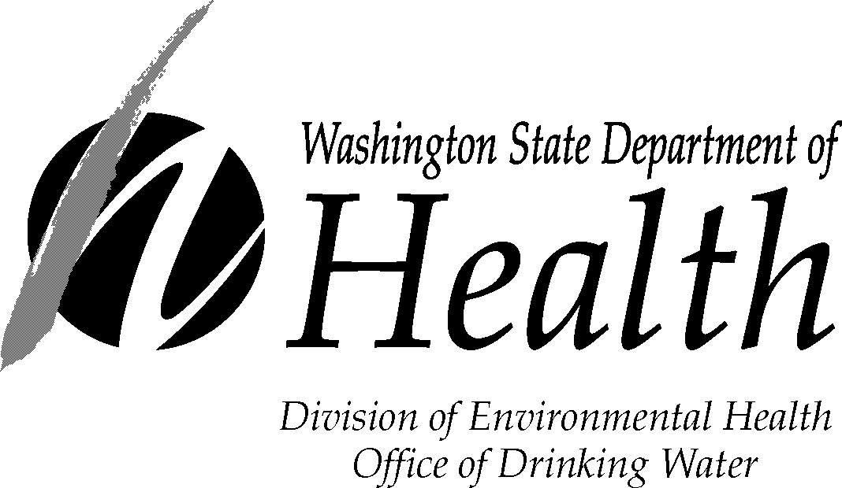

GWI Water Quality Monitoring Confirmation Form

System Name: County:______
System ID#: Source #:___________
This form establishes water quality monitoring parameters and frequency, equipment and appropriate contact persons responsible for data collection. This form must be completed, signed and returned to the address below by the date set during the GWI Water Quality Monitoring Interview with DOH.

Please identify the parameters that you plan to monitor. Please check the mandatory parameters and indicate the frequency of testing to ensure both the department and the purveyor are in agreement regarding required monitoring.
Mandatory Optional
Parameter Frequency Parameter Frequency
Water temperature Total / Fecal Coliform
Air temperature¹ HPC² Bacteria
Conductivity Turbidity
Precipitation pH
¹Spring Source, otherwise optional
²Heterotrophic Plate Count

Please identify the manufacturer and model number of test equipment that has been purchased, or will be purchased for the monitoring parameters specified above. Please provide copies of the manufacturer’s information (catalogue sheets) specific to each instrument.

Equipment for Mandatory Monitoring
(Water Temperature) Laboratory Quality Thermometer
Conductivity meter: Manufacturer and Model
Location of Rain Gage
Equipment for Optional Monitoring
Coliform or HPC Bacteria: Certified Laboratory
Turbidity: Manufacturer and Model
pH: Manufacturer and Model

Please identify the staff member who will be responsible for collecting and reporting data:

Staff Member Position/Title Phone #

__
Water System Manager Date Monitoring Start Date

Return completed form to: GWI Program Lead
Department of Health, Office of Drinking Water
P.O. Box 47822
Olympia, WA 98504-7822

The Department of Health is an equal opportunity agency. For persons with disabilities, this document is available on request in other formats. To submit a request, please call 1-800-525-0127 (TTY 1-800-833-6388). For additional copies of this form, call 1-800-521-0323.

