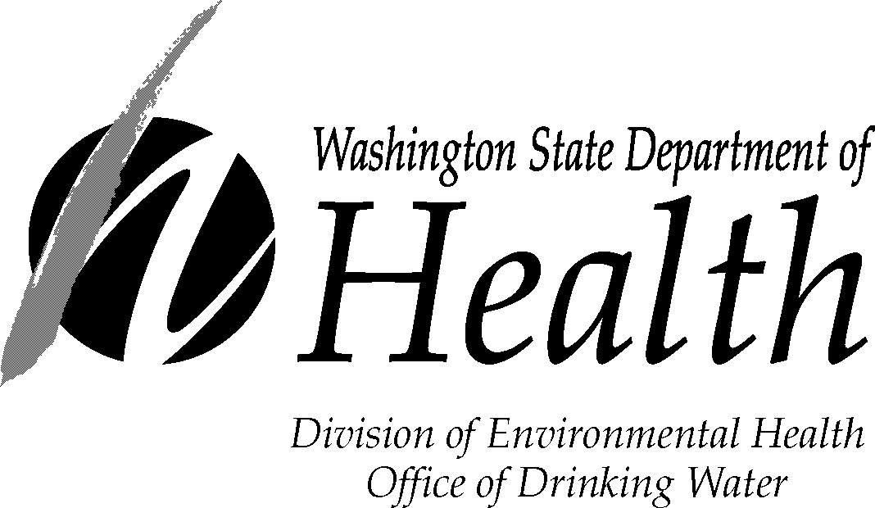

GWI WATER QUALITY MONITORING REPORT FORM
* To Be Completed Weekly *

System Name: |  |  |  |  |  |  | Month(s)/Year:
ID#: |  |  |  |  |  |  | Report Submitted By:
County: |  |  |  |  |  |  | Signature:
Source Name:
Source #: SO |  | Ranney/Inf.Gal. Spring Well |  |  |  |  | Phone Number:
Date/Time |  | Source |  |  |  |  | Surface Water |  |  | Precip. |  | Air | Weather, surface water
 | Temp (°C) | Conductivity  (μmohs/cm) | _____* |  | Temp (°C) |  | Conductivity  (μmohs/cm) | _____* |  | Level |  | Temp. | level, other information
* Optional: Coliform, HPC, Turbidity, pH

Return completed form to: GWI Program Lead, Department of Health, Office of Drinking Water, P.O. Box 47822, Olympia, WA 98504-7822
The Department of Health is an equal opportunity agency. For persons with disabilities, this document is available on request in other formats. To submit a request, please call 1-800-525-0127 (TTY 1-800-833-6388). For additional copies of this form, call 1-800-521-0323.

DOH Form #331-193 (01/07)

