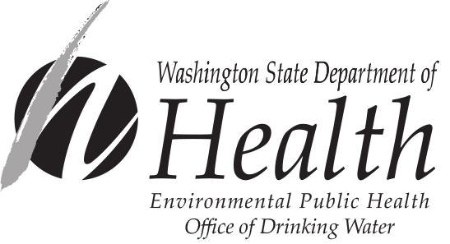
PUBLIC NOTICE
CERTIFICATION FORM
NITRATE MCL VIOLATION

Within 10 days of notifying your customers, you are required to send this completed form and a copy of each type of notice you distributed (hand-delivered notices, press releases, newspaper articles, etc.) to the appropriate Office of Drinking Water Regional Office (see address below). This form certifies that you have met all public notification requirements. If chemical contamination remains for more than three months, you must notify your water users again and provide another Public Notice Certification Form to the Department of Health.

With this certification, you are also stating that you will meet future requirements for notifying new billing units of the violation or situation.

Water System: __________________________________________ID #: __________County:_______________

Violation Date:_____ / _____ / _____ Violation Type:_____________________________________________

This public water system certifies that public notice has been given to water users following
state and federal requirements for delivery, content, and deadlines.

Complete the following items:

Yes No

Distribution was completed on ___ / ___ /____. Check all that apply:
Hand delivery,
Press release (TV, radio, newspaper, etc.),
Posting at_________________________ (by DOH approval only),
Other ____________________________ (by DOH approval only).

Were the water users notified within 24 hours?

______________________________________________ ___________________ ____________________
Signature of owner or operator Position Date

Northwest Regional Office:  PO Box 47800  Olympia WA 98504  Main Office: 253-395-6750  Fax: 253-395-6760  Area of Coverage: Island, King, Pierce, San Juan, Skagit, Snohomish, and Whatcom Counties | Southwest Regional Office:  243 Israel Road SE, Tumwater  PO Box 47823, Olympia WA 98504  Main Office: 360-236-3030  Fax: 360-664-8058  Area of Coverage: Clallam, Clark, Cowlitz, Grays Harbor, Jefferson, Kitsap, Lewis, Mason, Pacific, Skamania, Thurston, and Wahkiakum Counties. | Eastern Regional Office:  16201 East Indiana Ave., Suite 1500, Spokane Valley WA 99216  Main Office: 509-329-2100  Fax: 509-329-2104  Area of Coverage: Adams, Asotin, Benton, Chelan, Columbia, Douglas, Ferry, Franklin, Garfield, Grant, Kittitas, Klickitat, Lincoln, Okanogan, Pend Oreille, Spokane, Stevens, Walla Walla, Whitman, and Yakima Counties.

For people with disabilities, this document is available on request in other formats. To submit a request, please call 1-800-525-0127 (TDD/TTY call 711).

DOH Form 331-248 (Updated 10/13)

