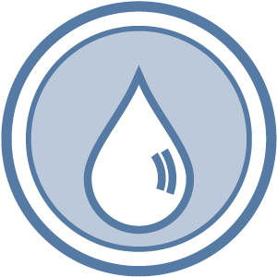
Public Notification Form
Public Notice Certification E. coli-MCL Violation
331-264-F • Updated 3/25/2022

Within ten days after notifying your customers about an E. coli-MCL violation, you must complete this form and send it to our regional office. You must also send a copy of each type of notice you distributed to your customers (hand-delivered notices, news releases, newspaper articles, and so on).

By completing this form, you certify that:
- You met all of the public notification requirements.
- You will meet future requirements for notifying new billing units of the violation or situation.

If the boil water advisory remains in effect more than three months, you must re-notify your water users and send another completed copy of this Public Notice Certification to us.

Complete the following items, sign the form and mail it to the nearest regional office, addresses below.
Water System: ID # County:

Violation Date: / / Violation Type

This public water system certifies that it gave this public notice to water users, following state and federal requirements for delivery, content, and deadlines. | Yes  No

Distribution was completed Yes No on / / .

Check all that apply:
Hand delivery,
News release (TV, radio, newspaper)
Posting at (by DOH approval only),
Other (by DOH approval only).

Were the water users notified within 24 hours? Yes No

Signature of owner or operator Position Date

Northwest Regional Office
PO Box 47800
Olympia WA 98504 (253) 395-6775
Fax: (253) 395-6760
Email: ingrid.salmon@doh.wa.gov
Southwest Regional Office
PO Box 47823
Olympia WA 98504-7823
(360) 236-3030
Fax (360) 236-3029
Email: swro.coli@doh.wa.gov
Eastern Regional Office
16201 E Indiana Ave Suite 1500
Spokane Valley WA 99216
(509) 329-2100
Fax: (509) 329-2104
Email: joseph.perkins@doh.wa.gov

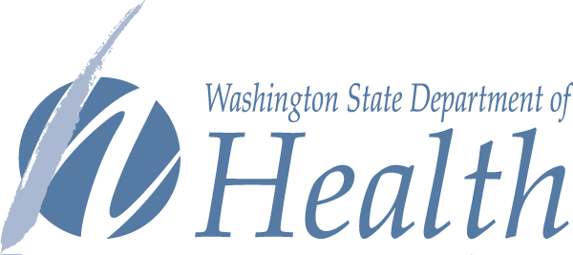
To request this document in another format, call 1-800-525-0127. Deaf or hard of hearing customers, please call 711 (Washington Relay) or email civil.rights@doh.wa.gov.

