NOTICE TO WATER SYSTEM USERS

DISINFECTION BYPRODUCTS MONITORING VIOLATION

We, Water System, I.D. , located in County are required to monitor your drinking water for specific contaminants on a regular basis Results of regular monitoring are an indicator of whether or not your drinking water meets health standards. During the month(s) of ___________ ___________________ or quarter(s) ______________ in the year of __________ we did not monitor or test for Total Trihalomethanes, Haloacetic Acids, or Bromate and therefore cannot be sure of the quality of your drinking water during that time.

At this time:
- No action is required by the users.

- Samples will be collected in the future as required.

- Other information for customers:

For more information, contact ____________________ at ( )_________ or at ____________________.
(owner or operator) (phone number) (address)

Please share this information with all the other people who drink this water, especially those who may not have received this notice directly (for example, people in apartments, nursing homes, schools, and businesses.) You can do this by posting this notice in a public place or distributing copies by hand or mail.

This notice is sent to you by ____________________________________ Water System on ____/____/____

Disinfection Byproducts Monitoring Public Notice Certification Form
The purpose of this form (below) is to provide documentation to the department that public notice was distributed.
Please check the appropriate box and fill in the date that the notice was distributed:
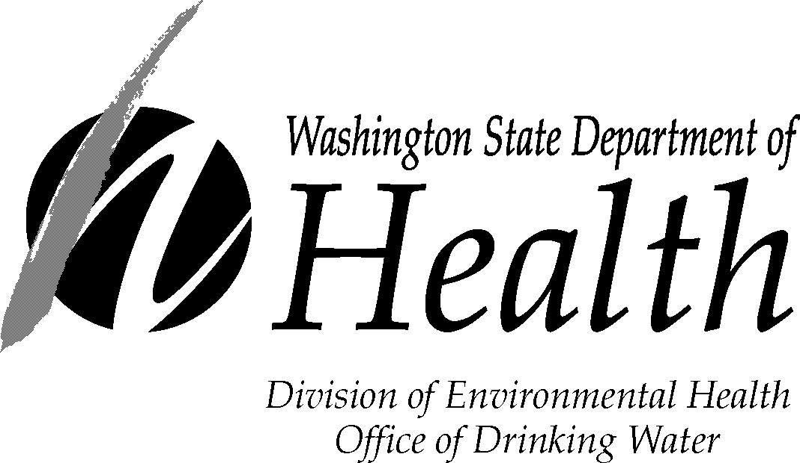
◻ Notice was mailed to all water customers on ____ / ____/____.
◻ Notice was hand delivered to all water customers on ___ / ___ /___.
◻ Notice was posted (with department approval) at:
____________________________________ on ___ / ___ /____.

____________________________________ ___________________ ____________________
Signature of owner or operator Position Date

If you need this publication in an alternate format, call (800) 525-0127. For TTY/TDD call (800) 833-6388.
Send copy of completed notification and certification to:
Northwest Drinking Water  Department of Health  20425 72nd Ave S, Suite 310  Kent, WA 98032-2358  Phone: (253) 395-6750  Fax: (253) 395-6760 | Southwest Drinking Water  Department of Health  PO Box 47823  Olympia, WA 98504-7823  Phone: (360) 236-3030  Fax: (360) 664-8058 | Eastern Drinking Water  Department of Health  16201 E Indiana Ave, Suite 1500  Spokane Valley, WA 99216  Phone: (509) 329-2100  Fax: (509) 329-2104

DOH Form 331-360 (Updated 08/10)

